To change or add new password for root user

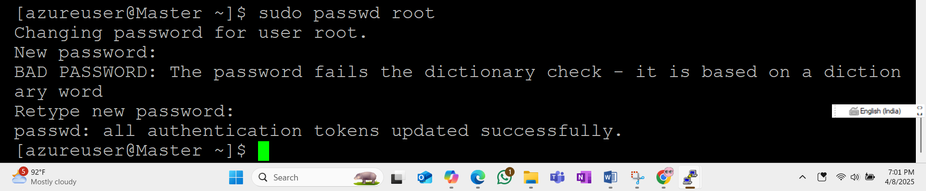

**Ansible setup on Redhat 8.10**

**To change local user to root user 🡪 Sudo –i**

**To update os from root user---------------------🡪 dnf update**

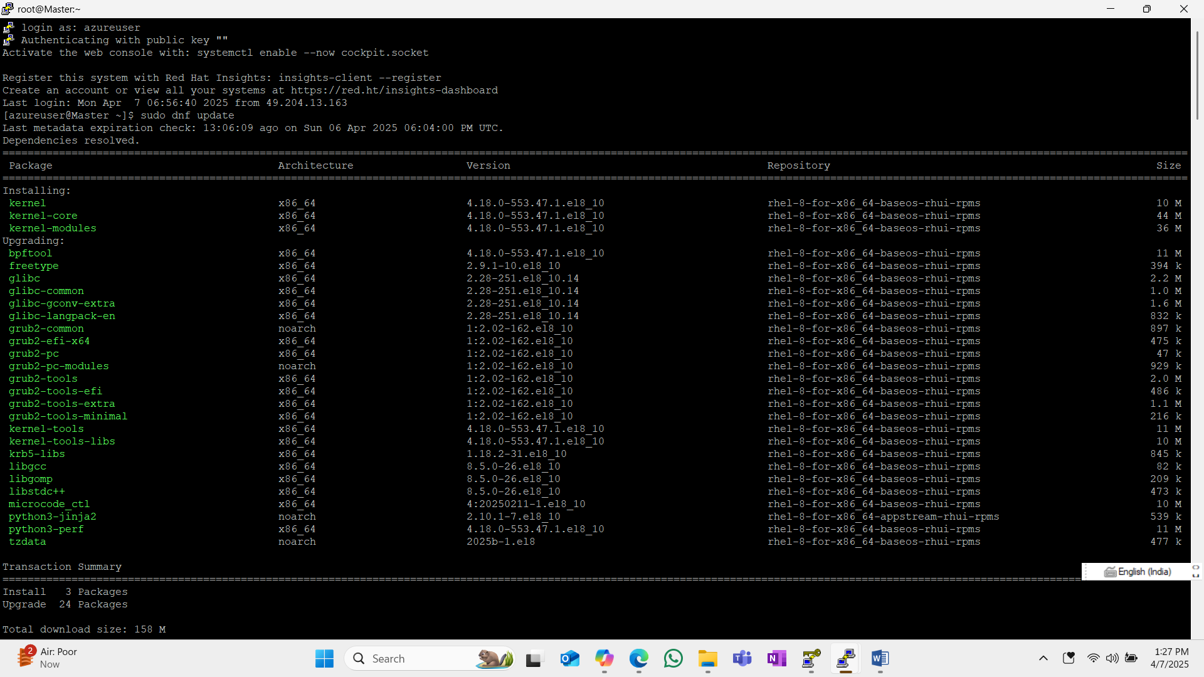

**sudo dnf install python3**

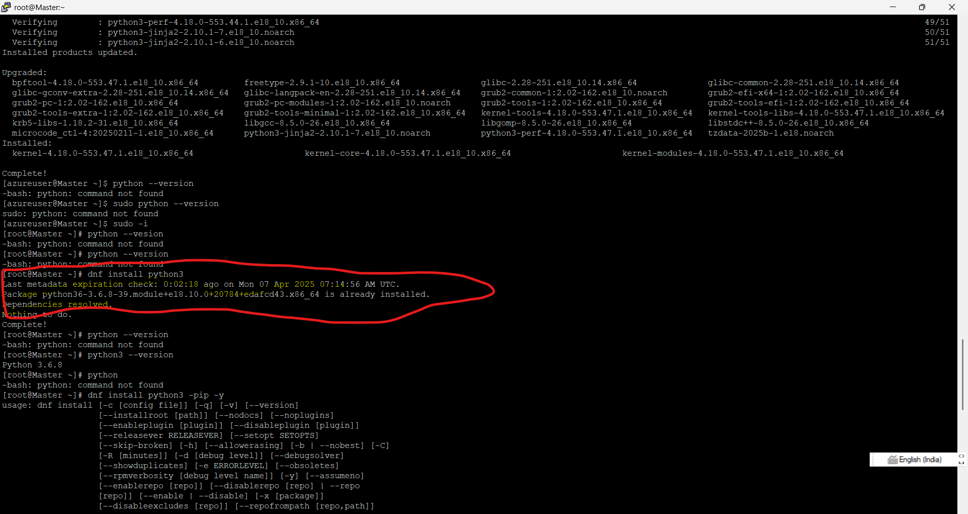

**Install Python**: Ansible requires Python. Use the command:

sudo dnf install python3

Verify the installation with:

python3 --version

dnf install python3

* python3 --version
* dnf install python3-pip –y

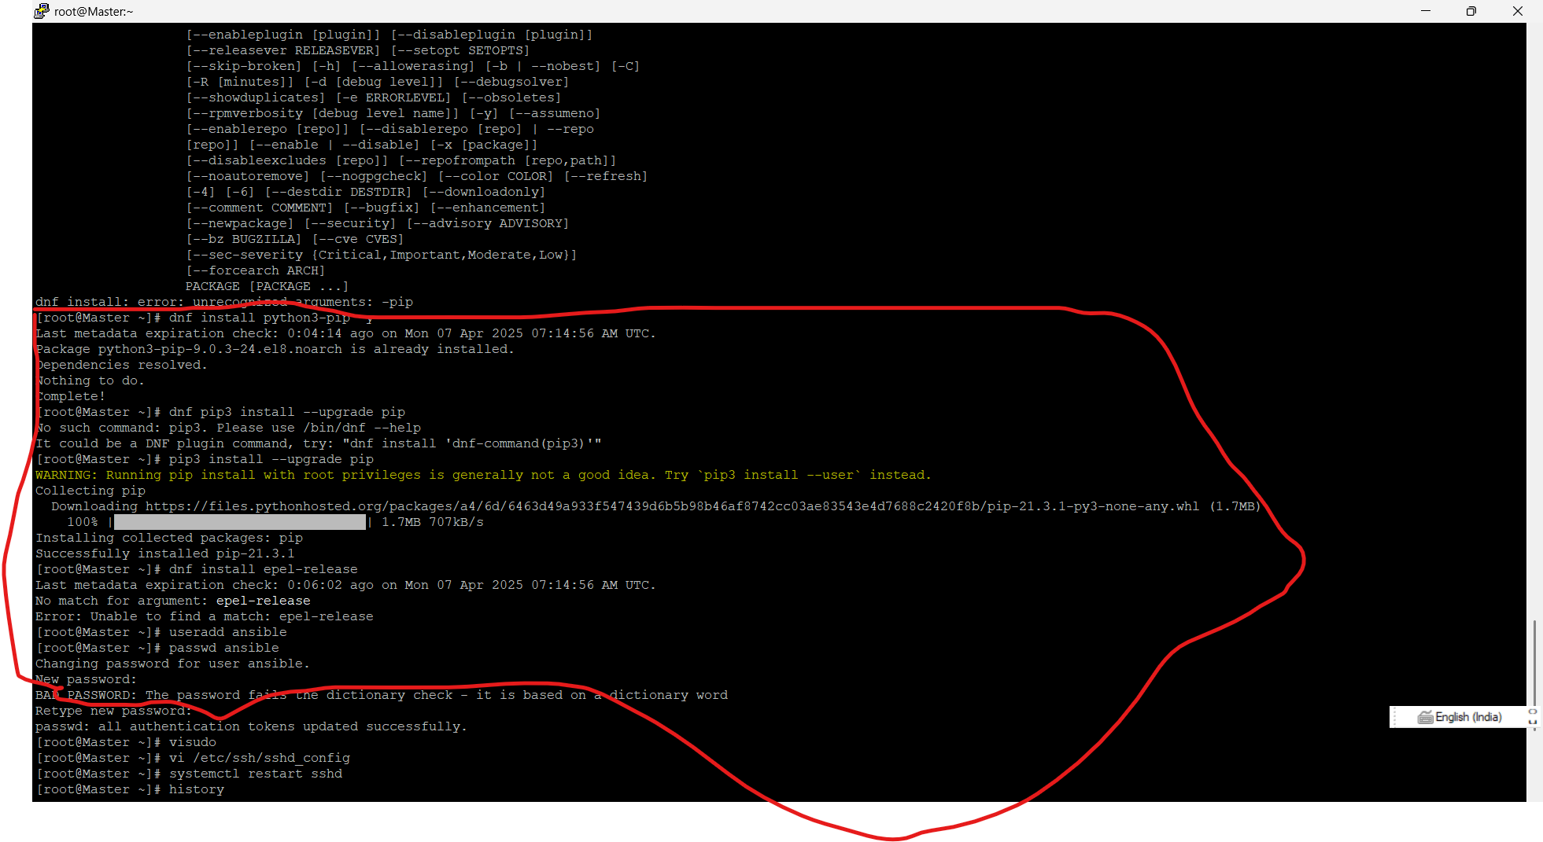

* dnf pip3 install --upgrade pip
* pip3 install --upgrade pip
* 1. useradd ansible
* 2. passwd ansible🡪P@55w0rd!

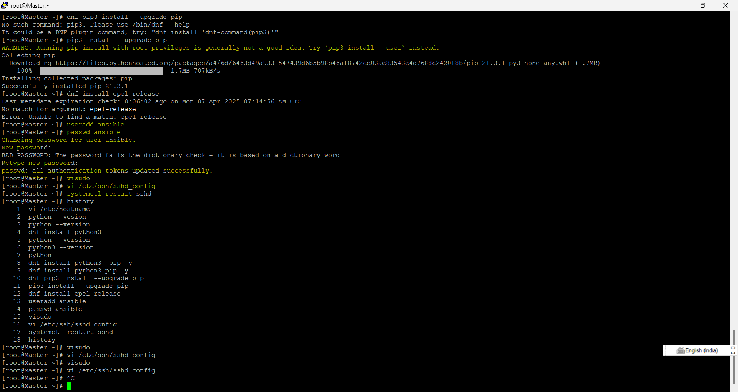

* 3. Visudo

Set command shift : 100 or 100 gg 🡪 copy the line (yy) 🡪root ALL=(ALL) ALL

Paste the line (p) and change to newuser 🡪ansible ALL=(ALL) NOPASSWD : ALL

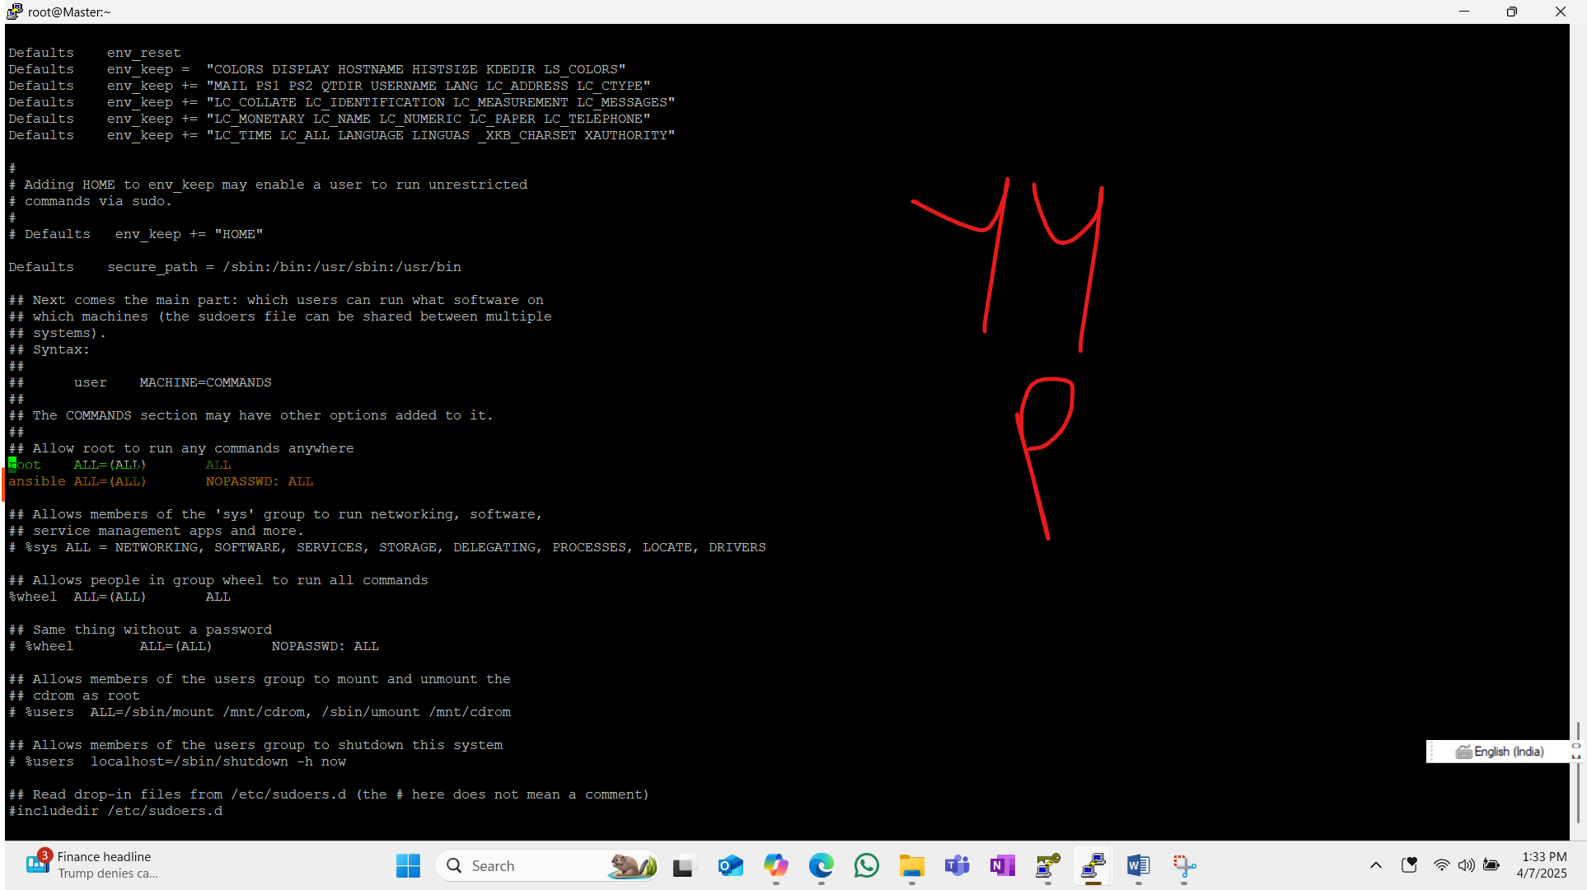

* 4. vi /etc/ssh/sshd_config

set command shift:71 or 71gg

passwordauthenticatio No 🡪yes

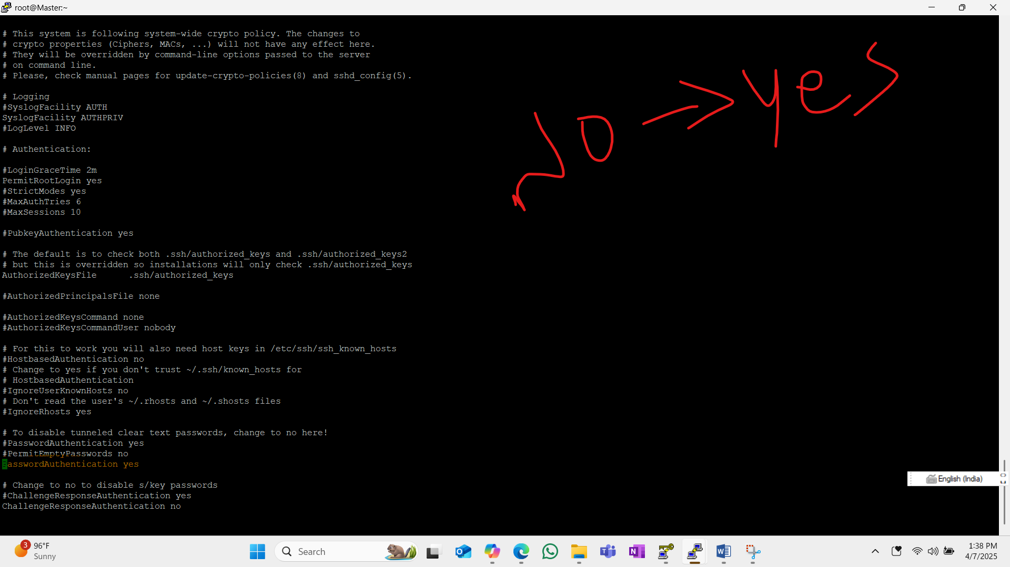

* 5. systemctl restart sshd

We have to perform above all steps from create new user to systemctls restart sshd on all slave machines.

Below is the steps To install ansible on Redhat 8.10 after installing dependency

To install ansible🡪def install ansible

To check the version 🡪 ansible --version

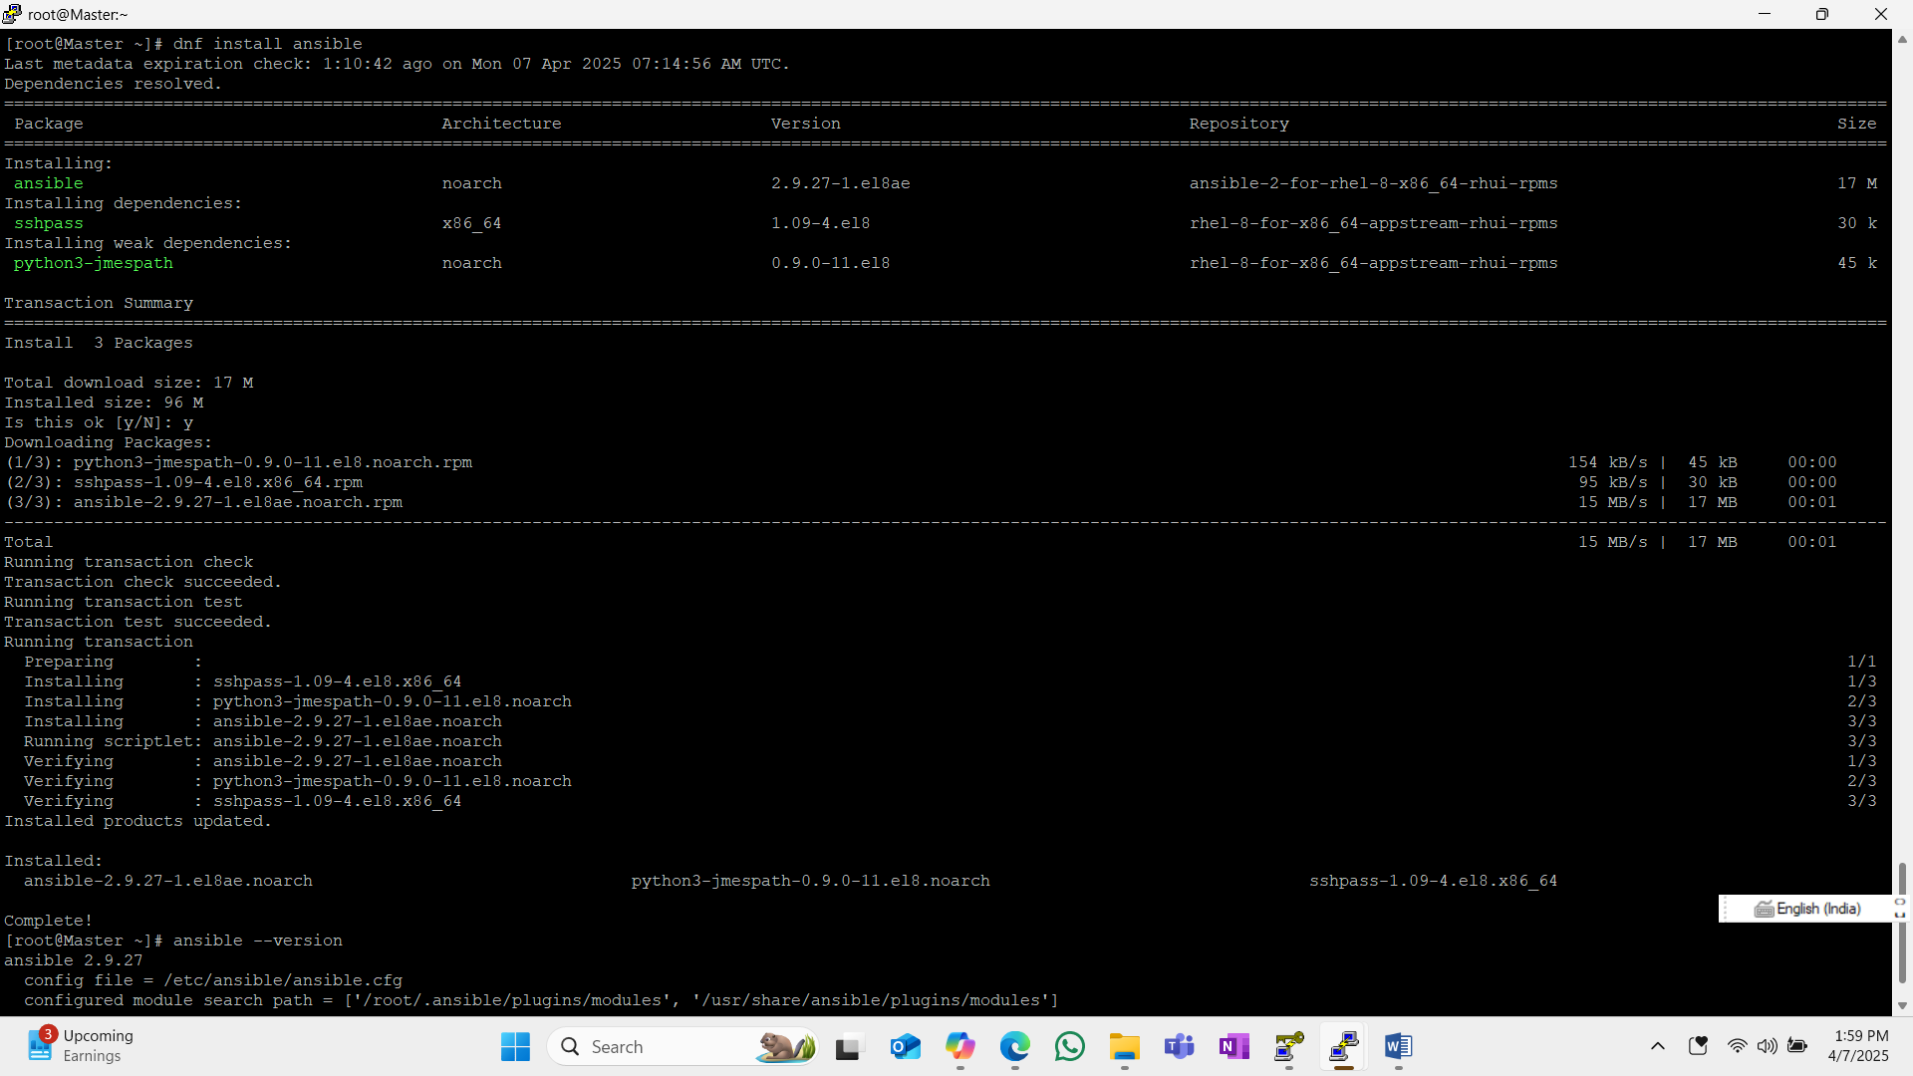

Now move to ansible path and add hosts on inventory

Vi /etc/ansible/ansible.cfg

Remove hash (#) before Inventory and sudo_user

Default static inventory of ansible is /etc/ansible/hosts

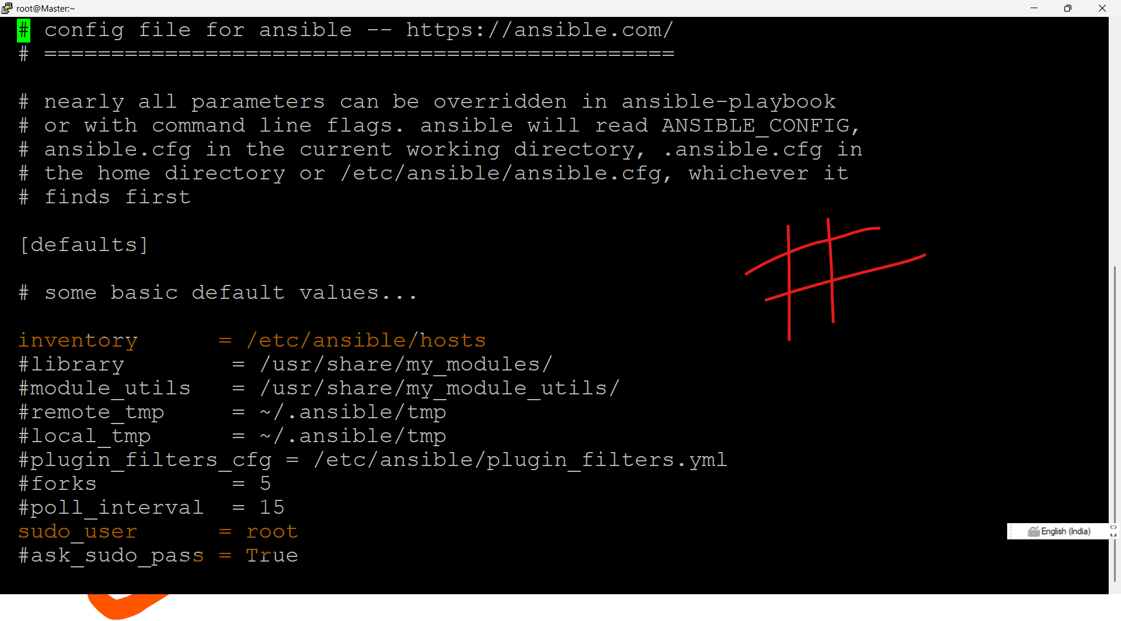

**We have to add (host) target ipaddress or slave ip address on under /etc/ansible/hosts**

**We have to give private ip’s of the slave machines or hostmachiens.**

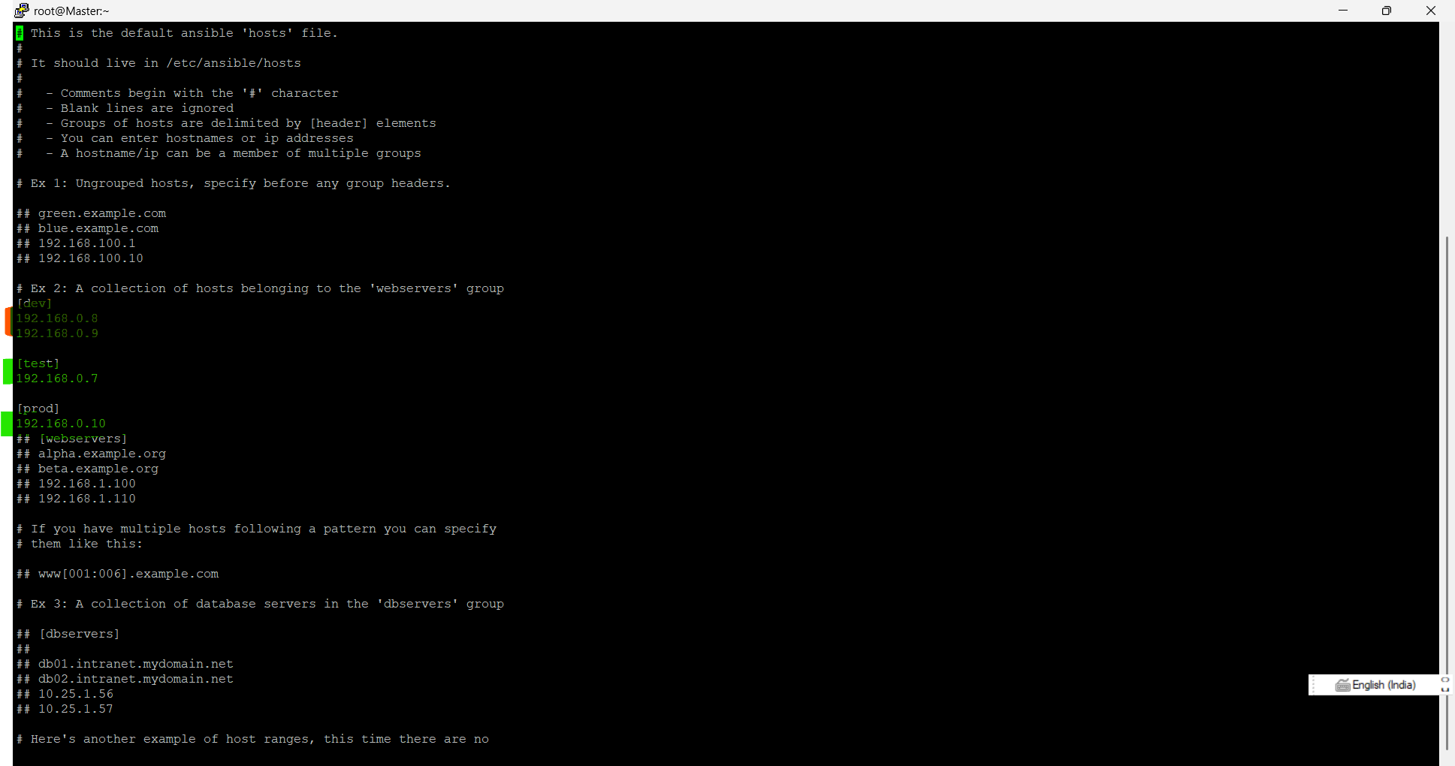

**After successfully added the hosts , we have to generate the ssh key on under ansibleuser**

**Su – ansible**

**[root@Master ~]# su - ansible**

**Last login: Mon Apr 7 08:55:02 UTC 2025 on pts/1**

**ssh-keygen🡪it will generate a new private and public key**

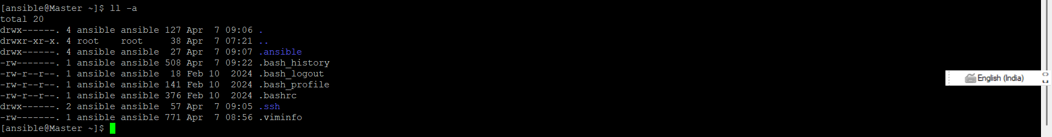

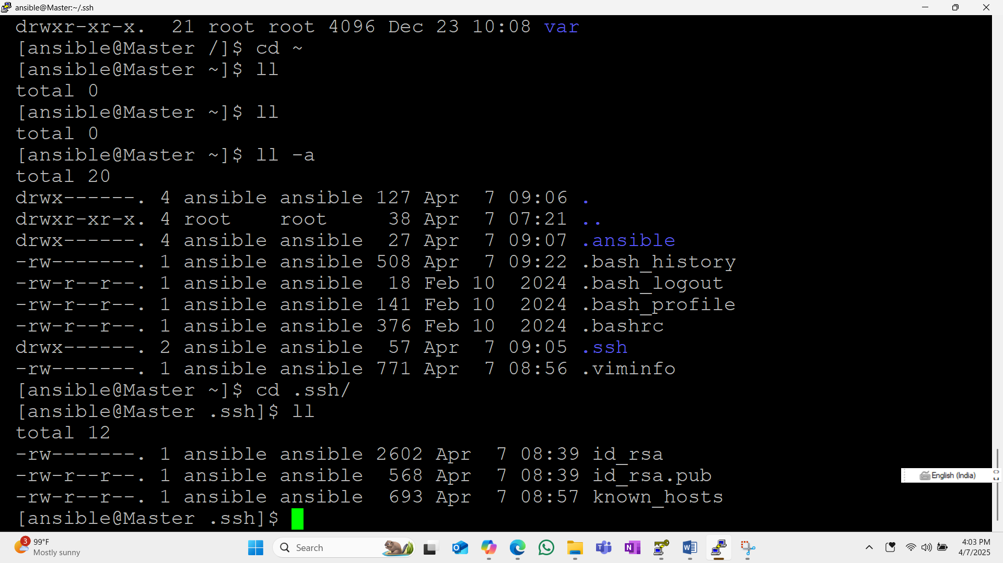

**Hear the above commands and data shows id_rsa is private key and id_rsa.pub is public kay**

**Hear if the public key and private key the both key will match then the ssh will be enabled**

**So if we copy the public key from master server to slave(host) the SSH connection will be enabled.**

**To copy the ssh key from master server to slave server we have to give username@ip of the server**

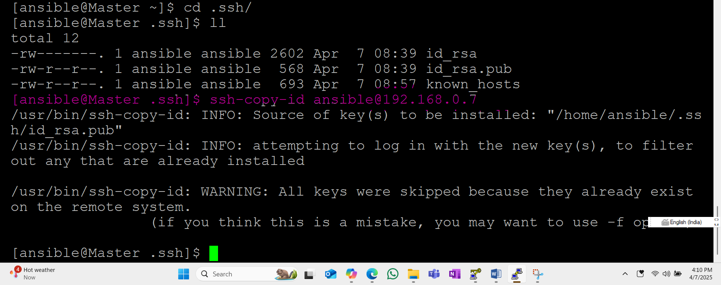

**I have already copy the ssh key from master to slave server so I got the above error , whenever we copy from the first time we have to give slave server password ex: I have created user name called ansible on my slave server and give root privileges to my user and my user password is (P@55w0rd!)**

**So I have given that password whenever it will ask.**

**Same way we have to all your slave servers.**

**Once it successfully copied ssh key to all your servers you can check it was copied sucussfully or not on your server by using below command or steps**

**To connect slave server from master you can use ssh slaveserver username @ipaddress**

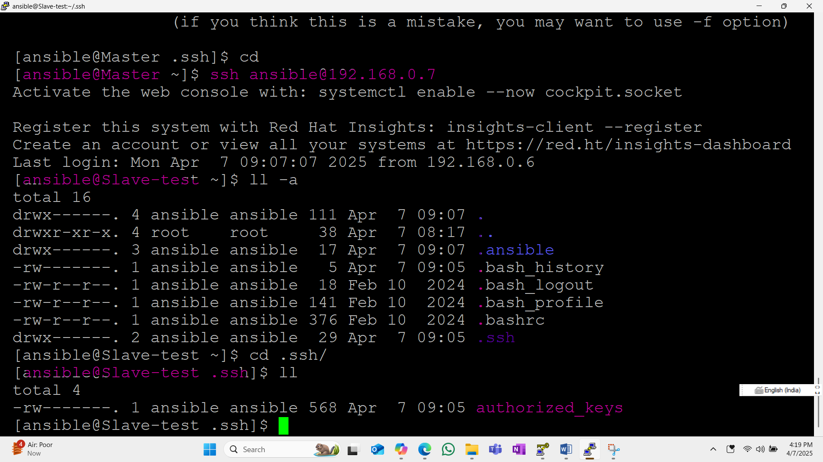

**Same way we have to check reaming all servers once it successfully completed we can check it was communicating or not by using below command**

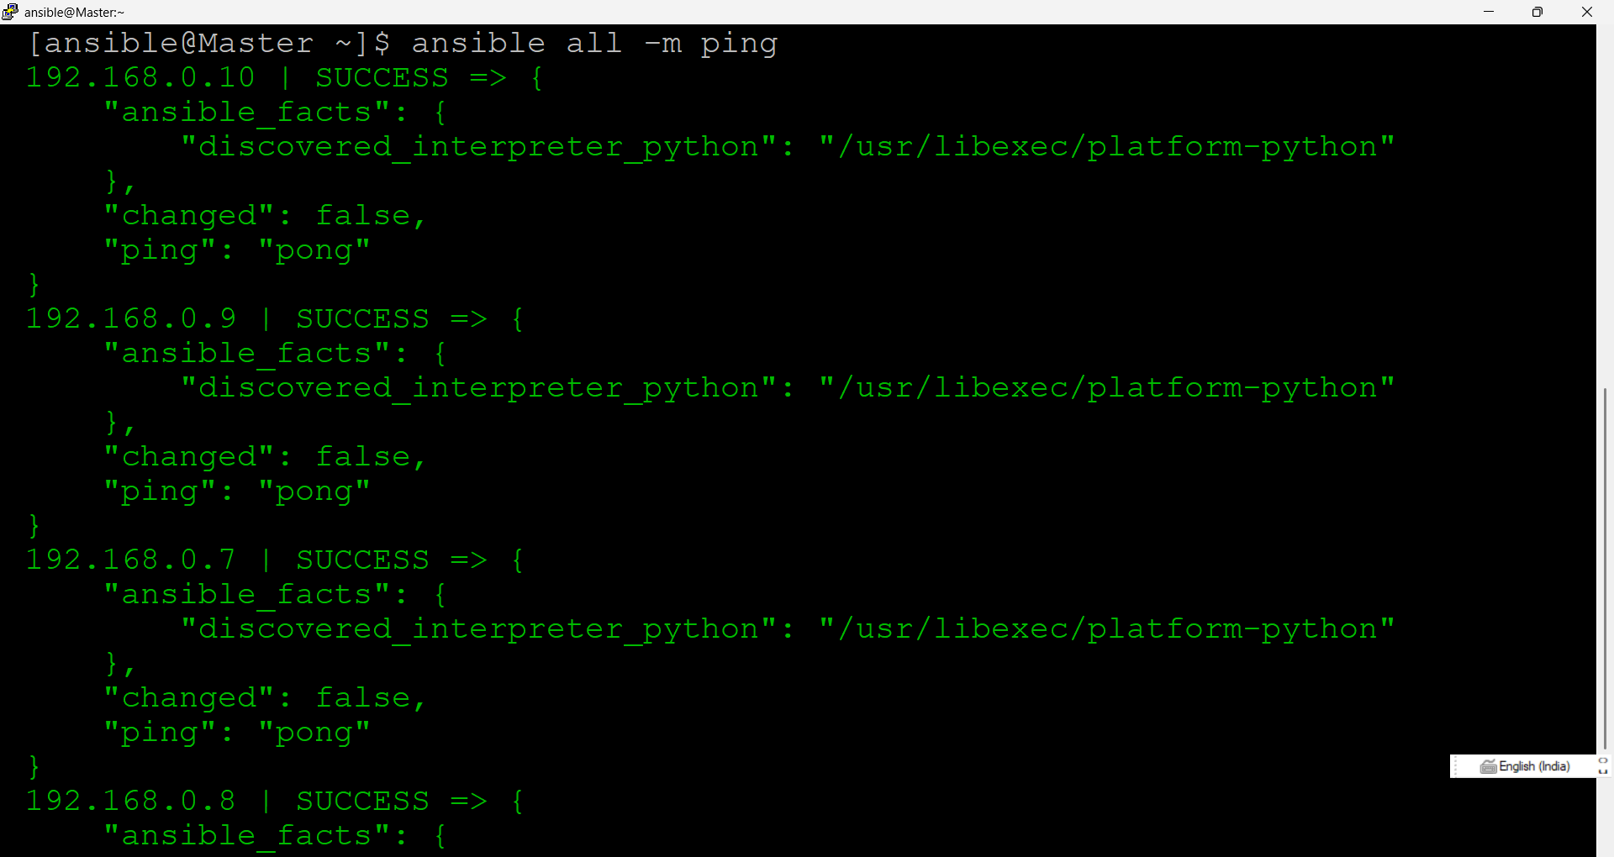

**Ansible all –list-hosts**

**Ansible dev –list-hosts**

**Ansible dev[0] –list-hosts**

**Ansible prod –list-hosts**

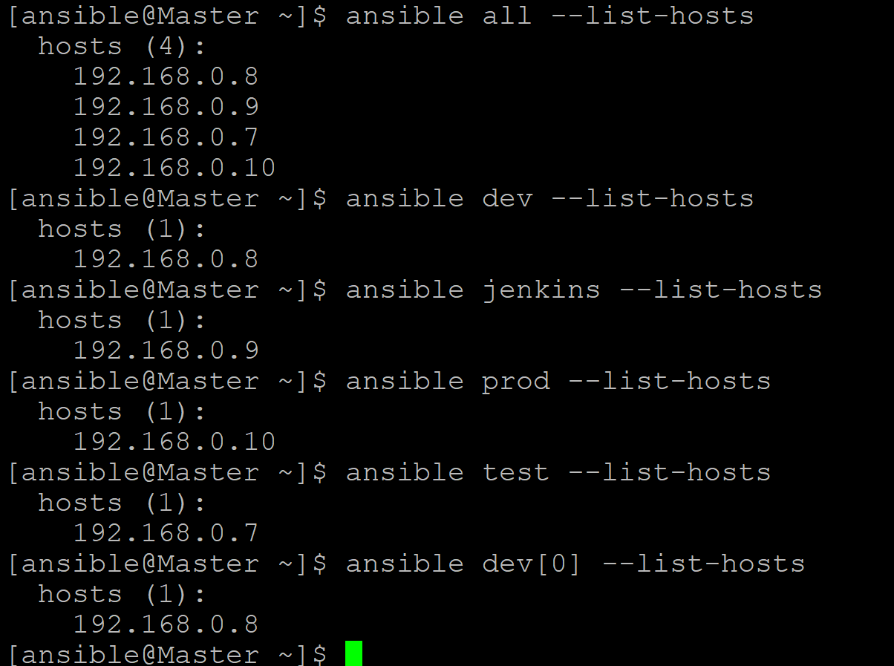

**History of all commands on under ansibleuser**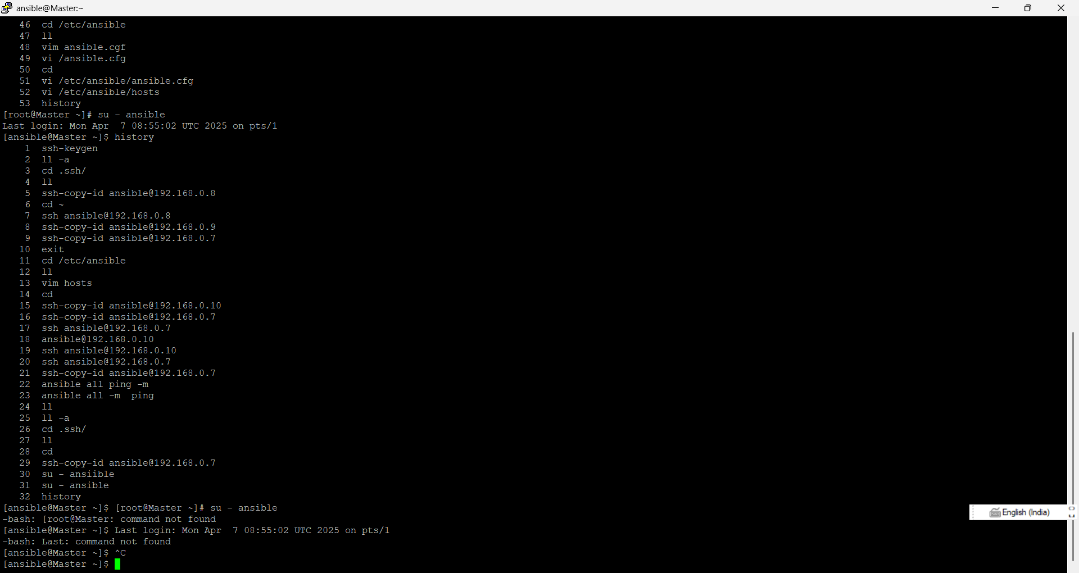

**Create play books**

**Whenever we created a play book the playbook file extension should be .yml or yaml**

**Ex (test.yml)**

**vim test.yml**

**structure of playbook**

**target**

**variables**

**task**

**target🡪 on which server we have to go for performing the tasks**

**task 🡪 on the target server which task we have perform**

**ex:**

**playbook start with (---) end with (…)**

**---**

**- hosts: test test🡪 group of host machines or we can one host server as well**

**user: ansible user🡪host machine username**

**become: yes become🡪authentication yes or not**

**connection: ssh connetion: how the master server connect to slave server**

**tasks:**

**- name: this task is for installing java1.8.0 on test server**

**action: dnf name=java-1.8.0-openjdk state=present**

**- name: this task is used to install git on test server**

**action: dnf name=git state=present**

**...**

**State**

**Different type of states**

1. **Install->present**
2. **Uninstall->absent**
3. **Update->latest**
4. **Start->started**
5. **Restart->restarted**
6. **Stop->stopped**

**Different types modules**

**Action : yum name=git state=present**

**Yum: name=git state=present**

**Command 🡪 we have to give full command**

**Command : yum install git –y state=present**

**Note: under tasks we are writing about on the above mentioned hosts which action we are going to perform**

**Tochech the indentation**

[YAMLlint - The YAML Validator](https://www.yamllint.com/)

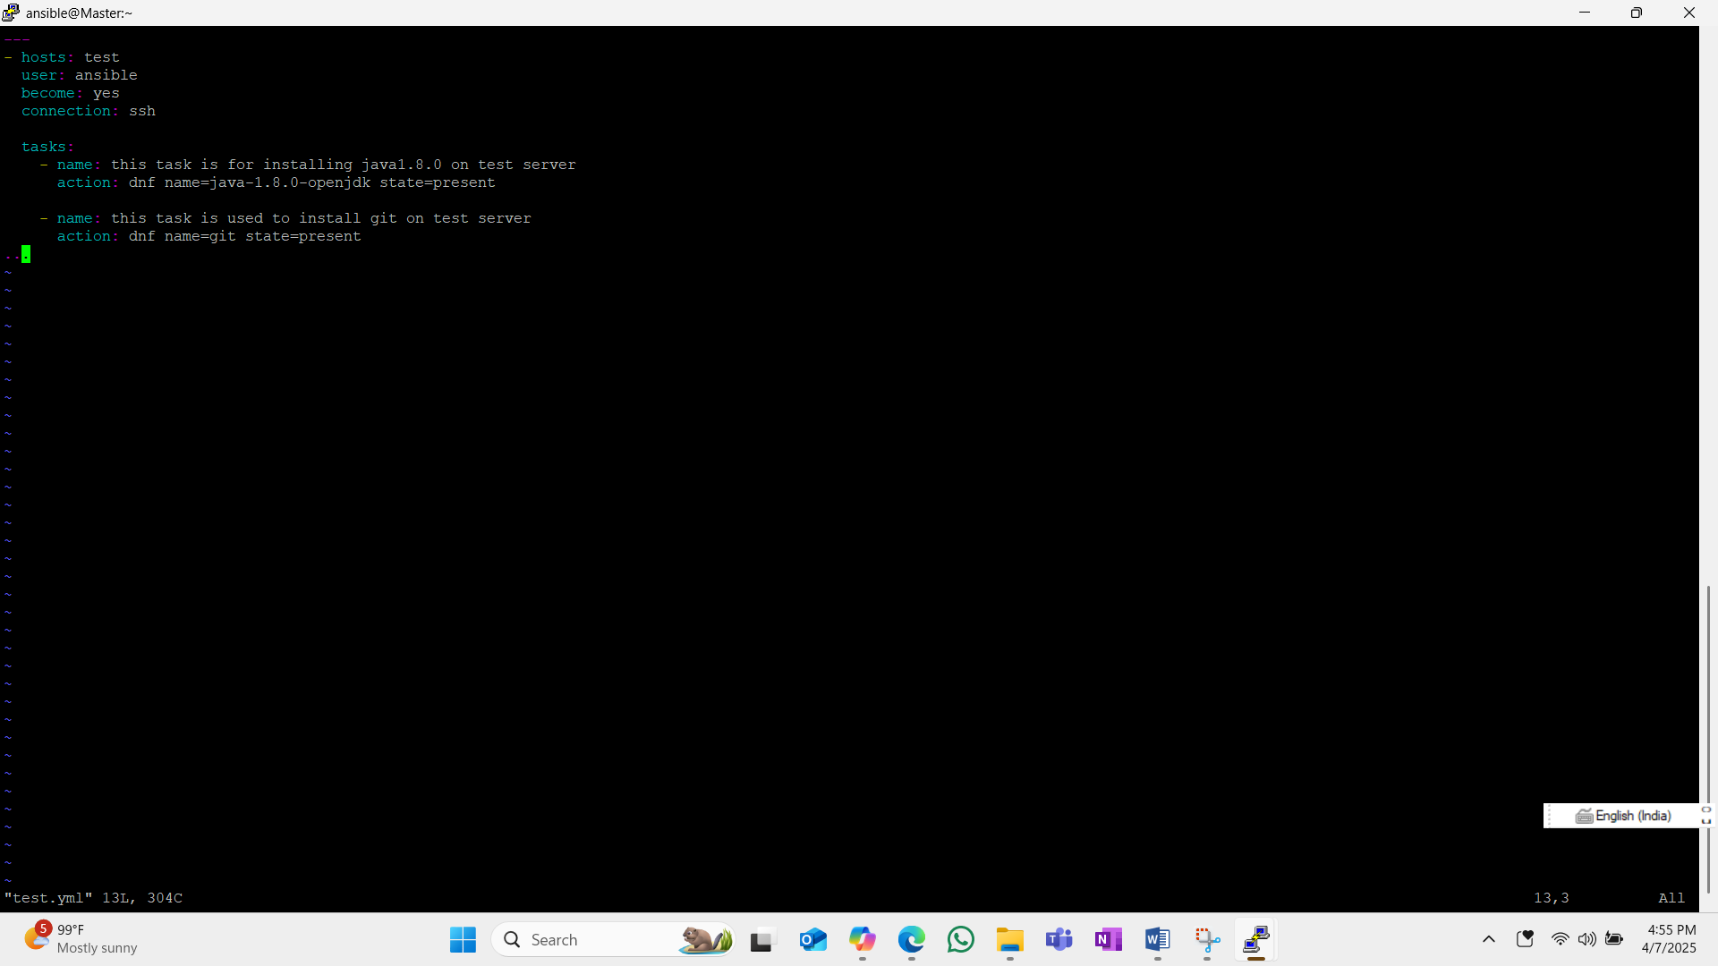

**:wq**

**ansible-playbook test.yml**

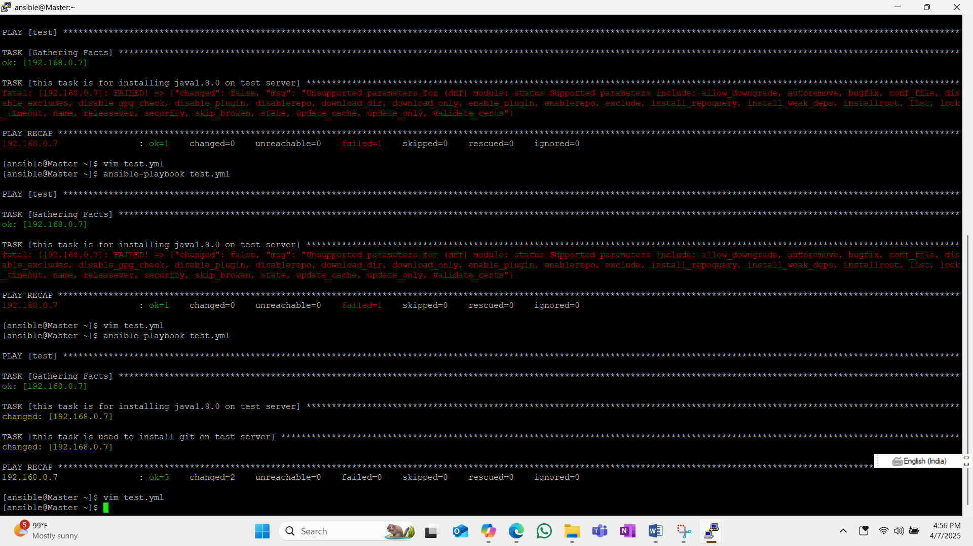

**After run the above command it will run the all task and the output will be you can see on below screen shot.**

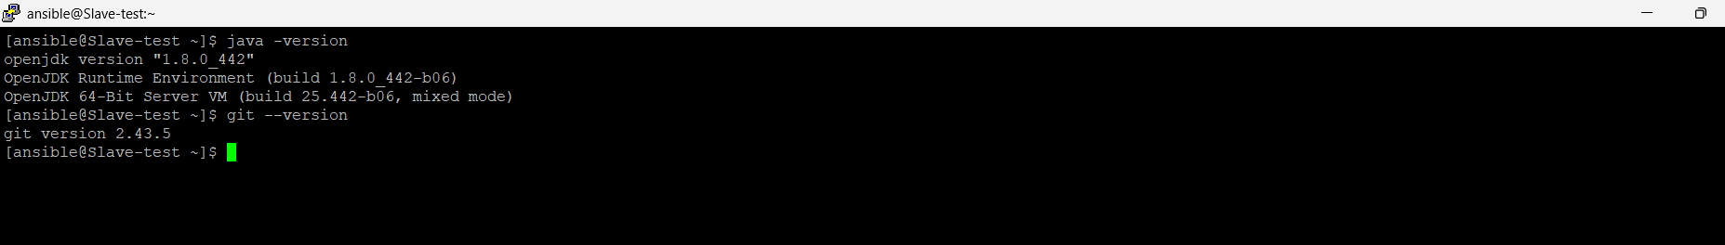

**Playbook 2**

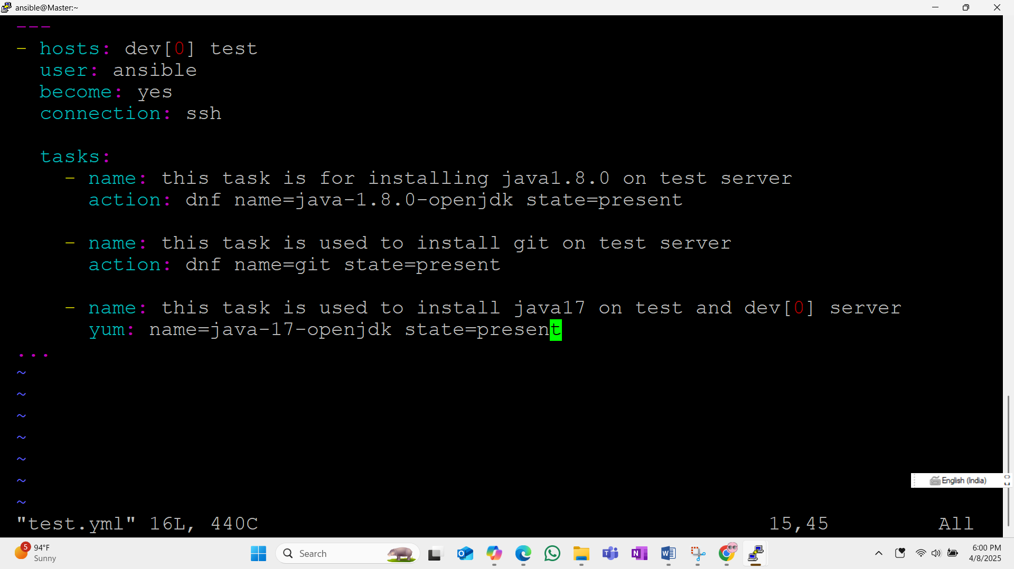

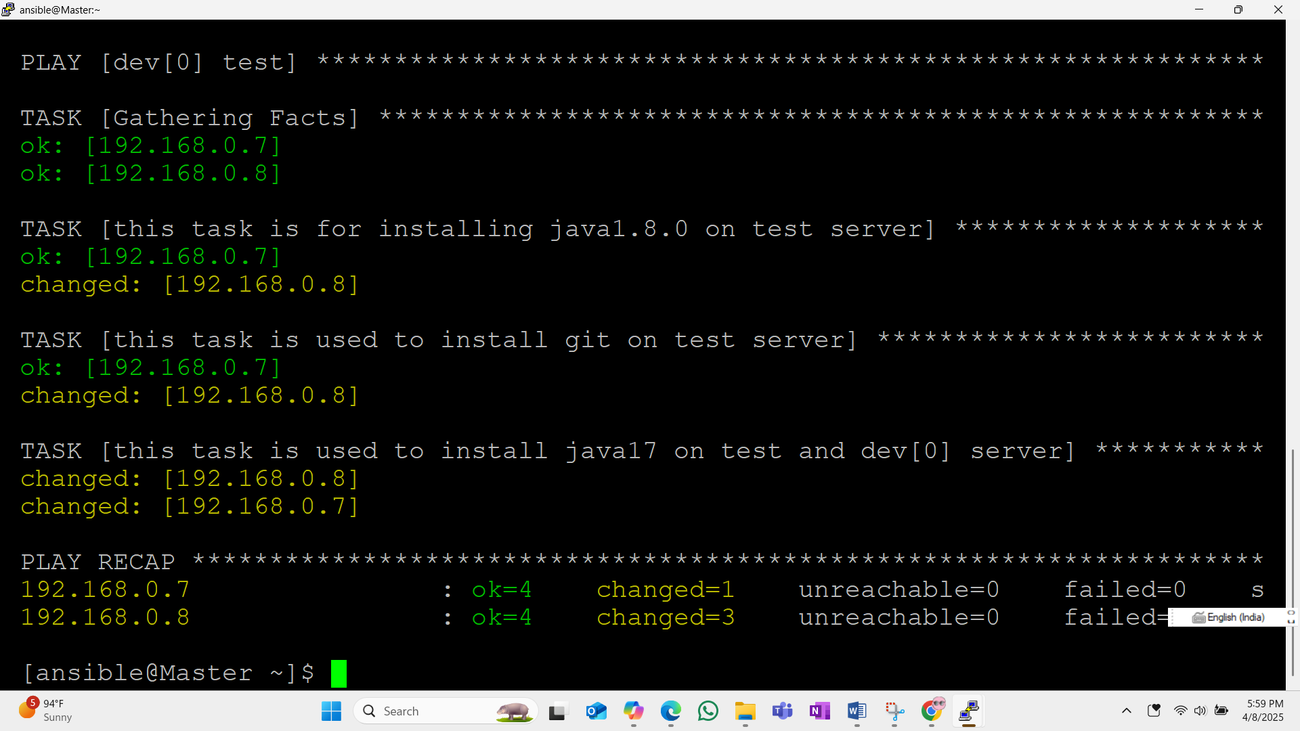

**Output**

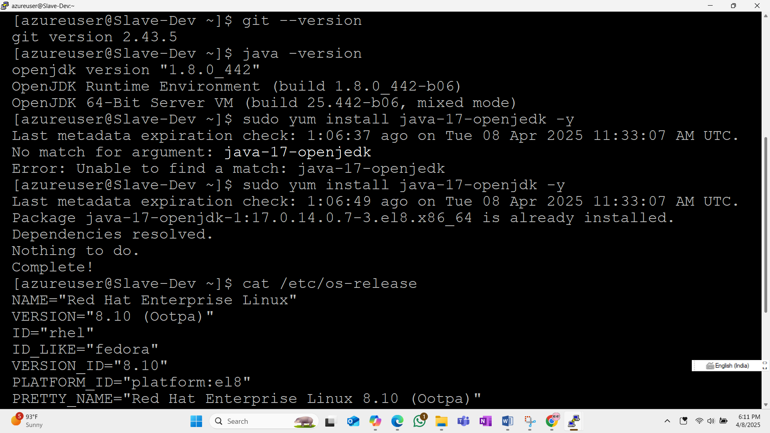

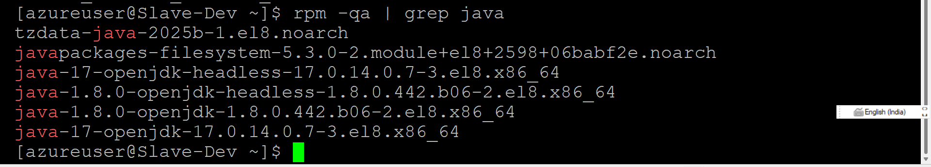

**2. Write a play book using vars**

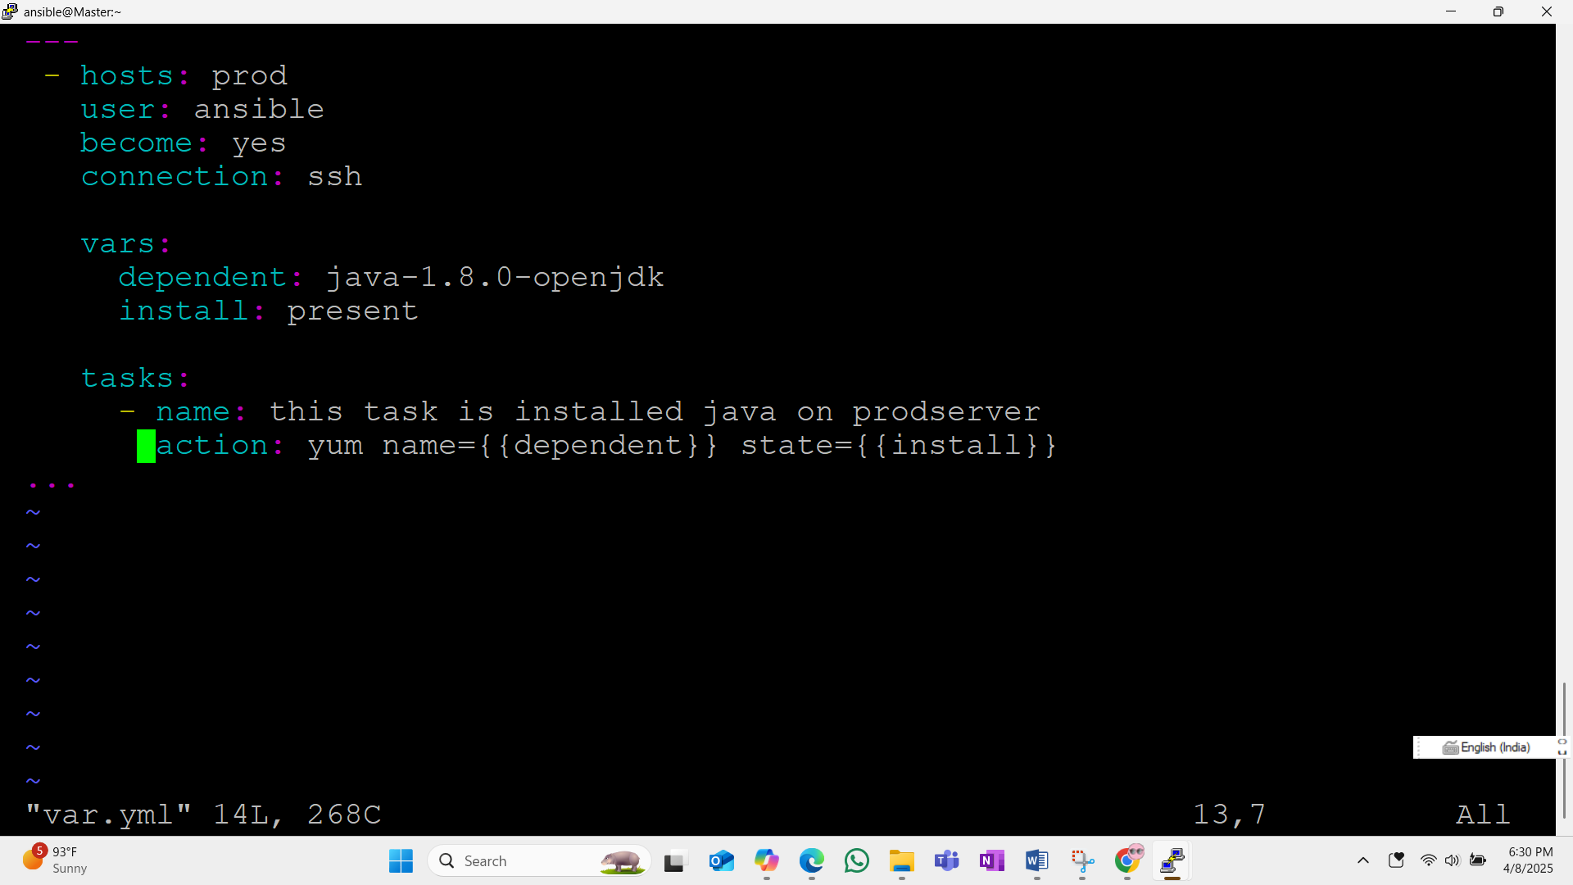

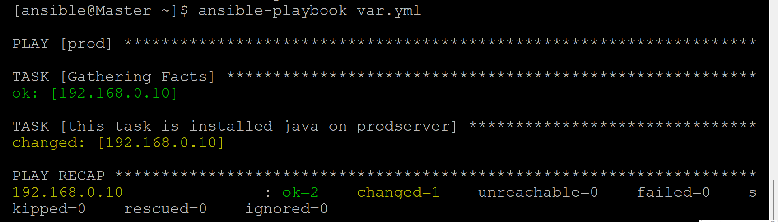

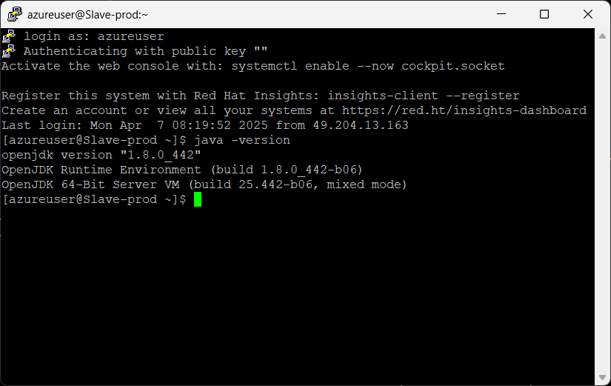

**3. write a play book give variable on run time**

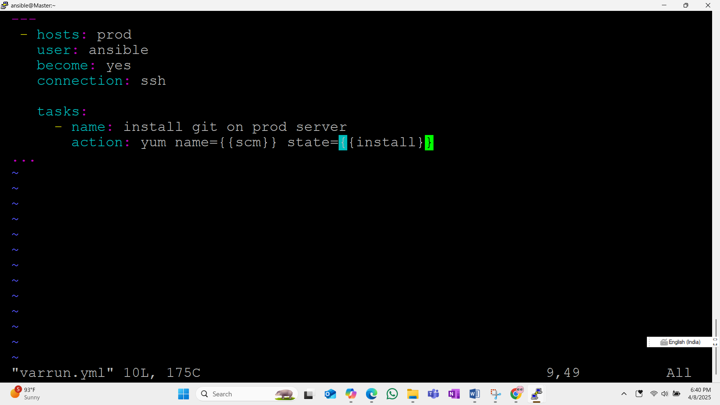

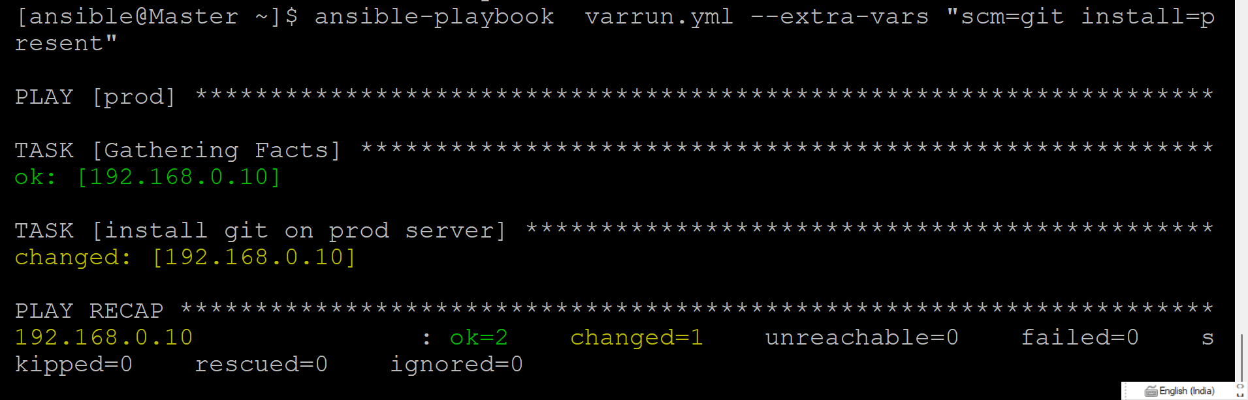

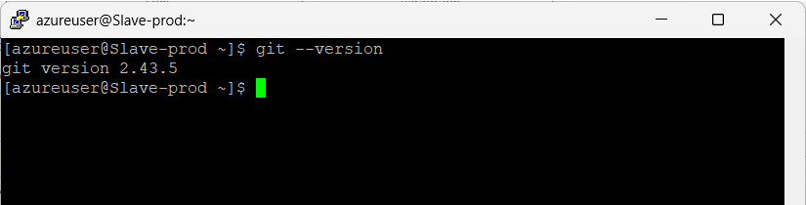

**To install httpd service on redhat 8.10**

Sudo yum install httpd

To check the status of the service🡪Systemctl status httpd

To start the service 🡪 Systemctl start httpd

Some times it will ask root password to start the service , if you know the root password you can give that ,if not we can create new password to root by using below command

Sudo passwd root



**Some times the service will run but when we try to acces the webpage will get error like**



**In this situation we have to add ports on below mentioned path**

**4. Need to set port configuration 8080 in vi /etc/httpd/conf/httpd.conf Give “Listen 8080” save it and**

**Restart it.**

* **vim /etc/httpd/conf/httpd.conf >> add Listen 8080**
* **systemctl status httpd**
* **systemctl restart httpd**
* **netstat -tuln | grep ':8080'**
* **netstat -tuln | grep ':80'**
* **sudo firewall-cmd --add-port=80/tcp --permanent**
* **sudo firewall-cmd --add-port=8080/tcp --permanent**
* **sudo firewall-cmd --reload**

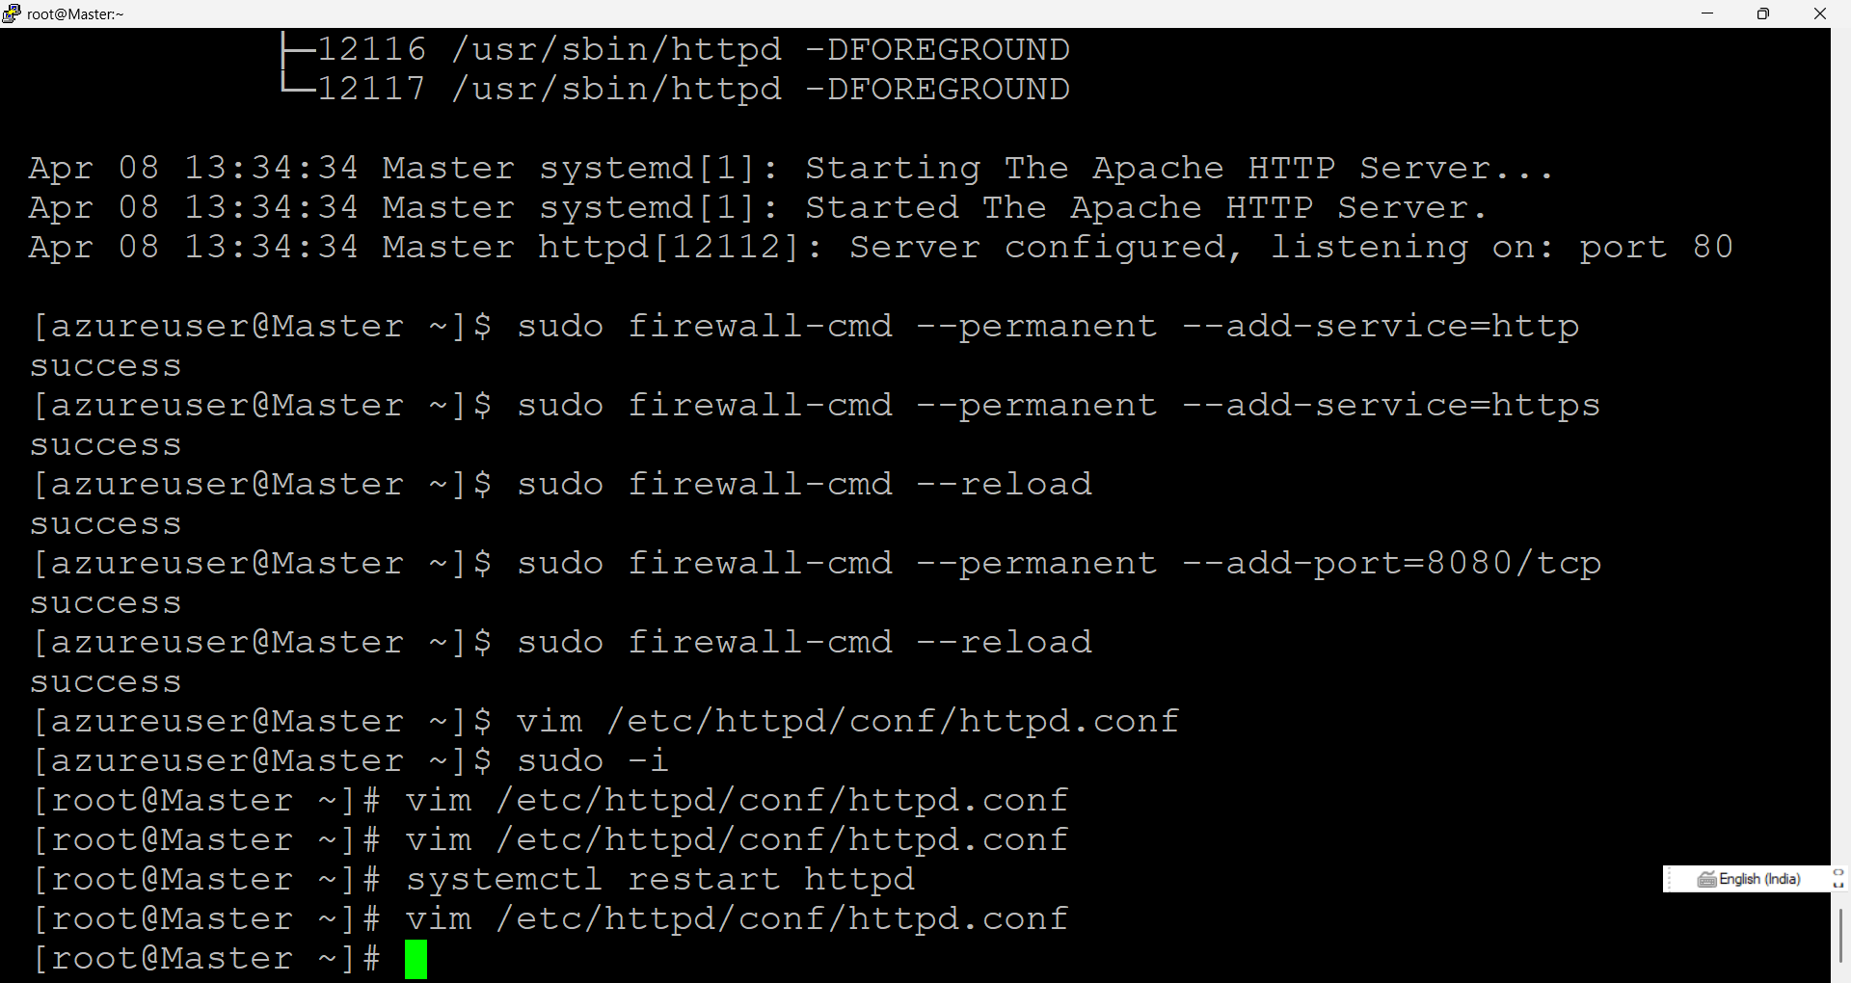

**4. Playbook for install httpd service**

**You can automate these steps in your virtual machine using Ansible playbooks. Below is an example of how to structure your playbook to perform these actions:**

**Example Ansible Playbook**

**---**

**- name: Configure VM to listen on ports 80 and 8080**

**hosts: your_vm**

**become: yes**

**tasks:**

**# Ensure Apache is installed**

**- name: Install Apache HTTP Server**

**yum:**

**name: httpd**

**state: present**

**# Update httpd.conf to listen on port 8080**

**- name: Add Listen 8080 to httpd.conf**

**lineinfile:**

**path: /etc/httpd/conf/httpd.conf**

**regexp: '^Listen 8080'**

**line: 'Listen 8080'**

**state: present**

**# Restart Apache**

**- name: Restart Apache**

**service:**

**name: httpd**

**state: restarted**

**# Check port listening (optional)**

**- name: Check ports using netstat**

**command: netstat -tuln**

**register: netstat_output**

**- debug:**

**var: netstat_output.stdout**

**# Add ports to the firewall**

**- name: Allow port 80 in firewall**

**firewalld:**

**port: 80/tcp**

**permanent: yes**

**state: enabled**

**- name: Allow port 8080 in firewall**

**firewalld:**

**port: 8080/tcp**

**permanent: yes**

**state: enabled**

**# Reload firewall to apply changes**

**- name: Reload firewall**

**command: firewall-cmd –reload**

**5. playbook for create a folder and file and insert some data in the file**

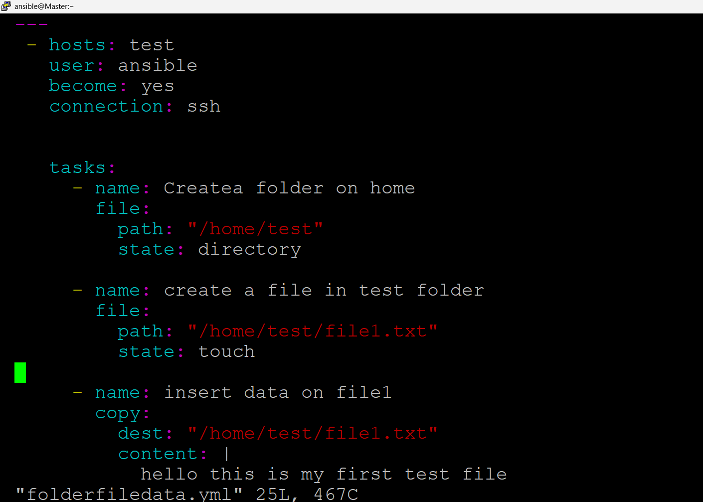

**Output**

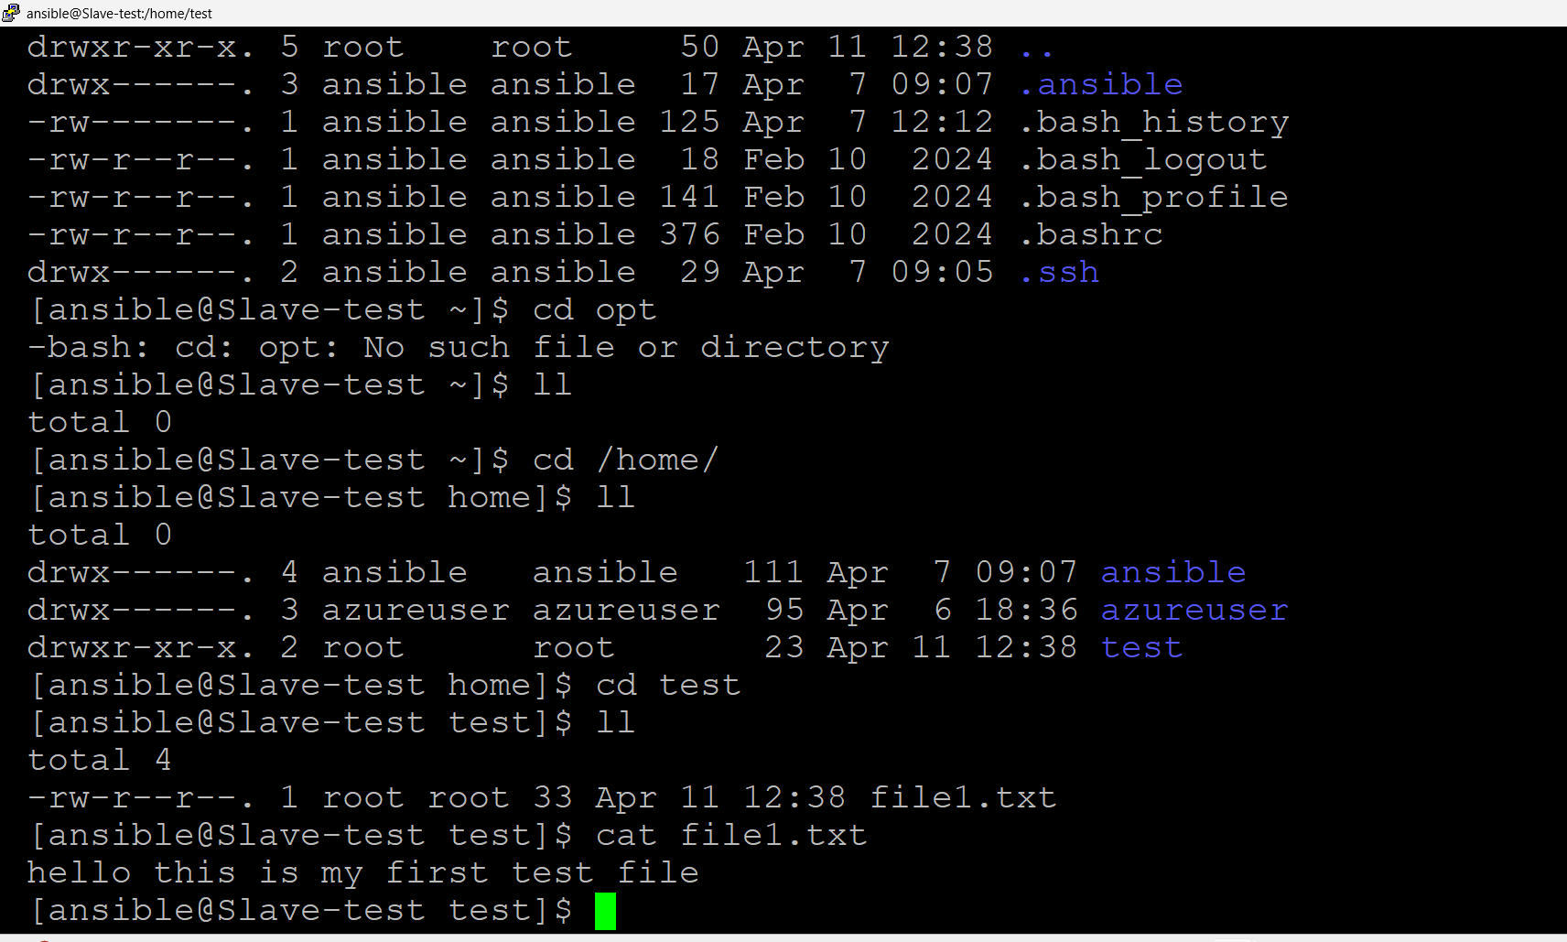

1. **Write a play book to install multiple services in sinlge task using loop**

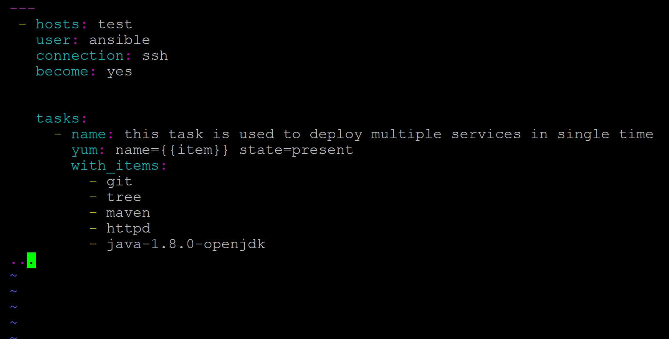

**I have already installad 3 services on this machine so here it’s installed only one**

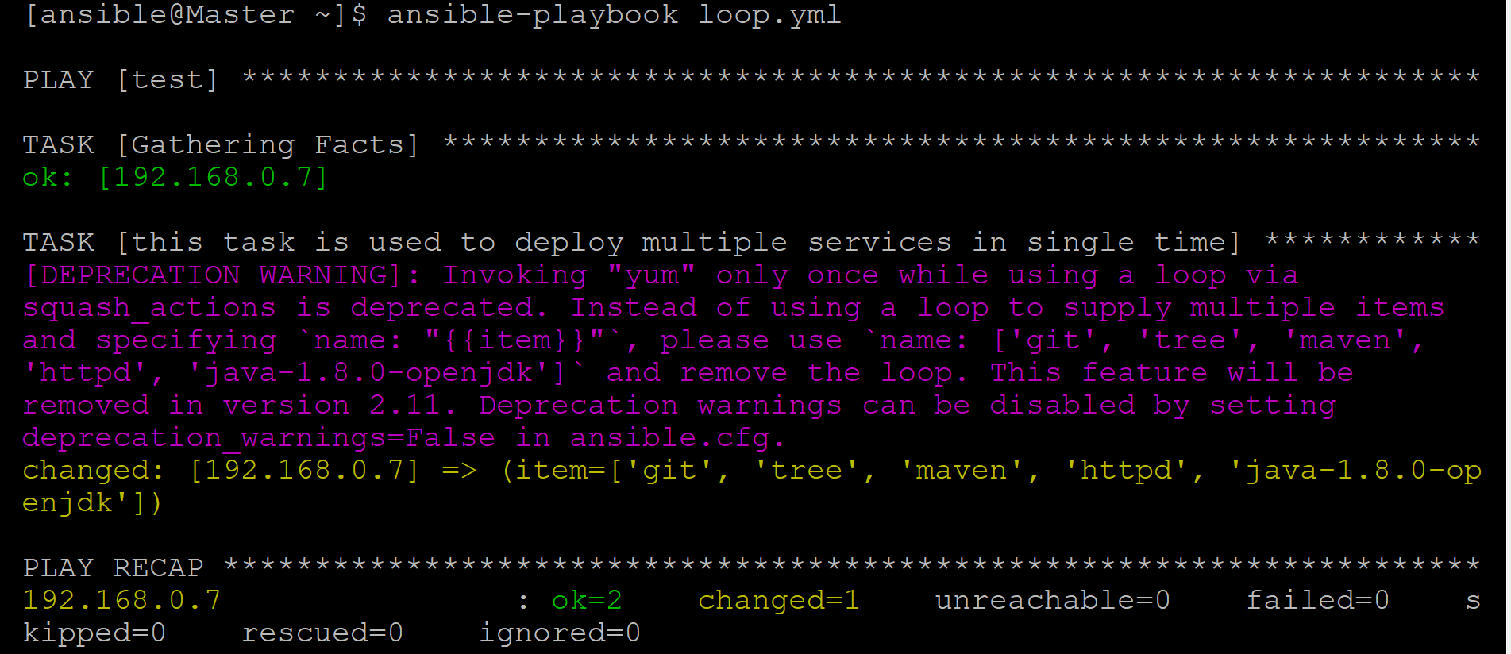

1. **Write a play book to create users and group in server**

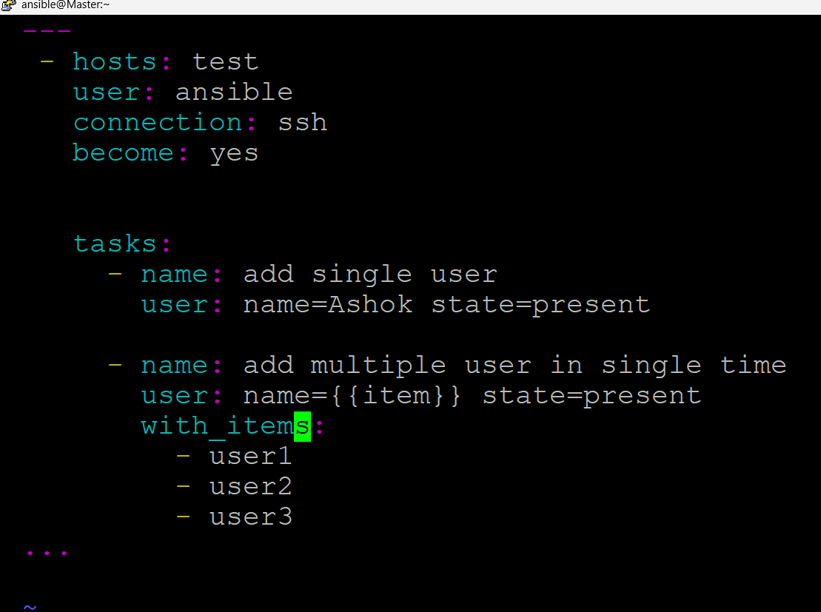

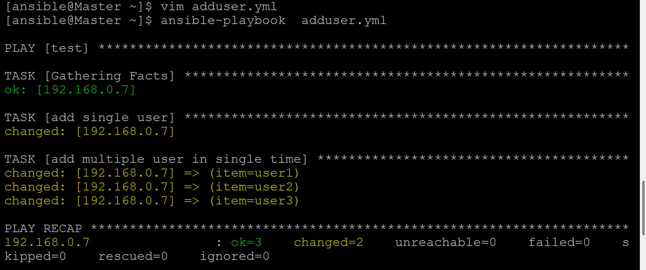

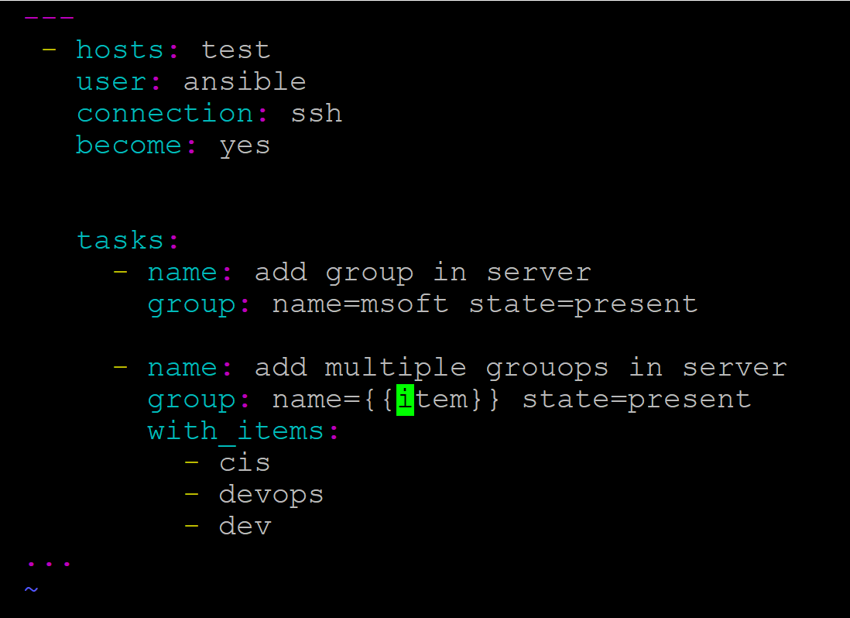

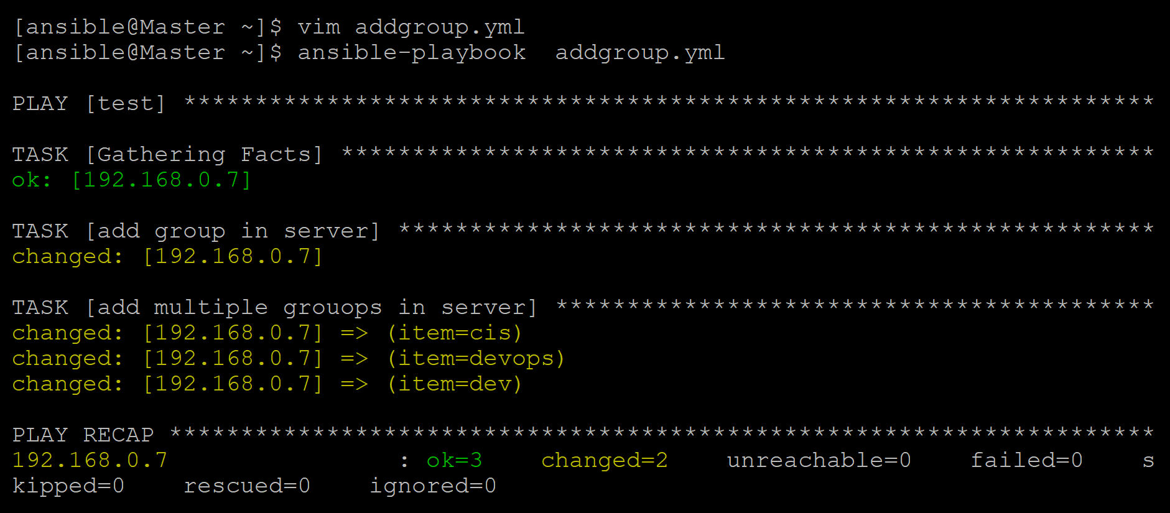

1. **write a playbook to install services using conditions**

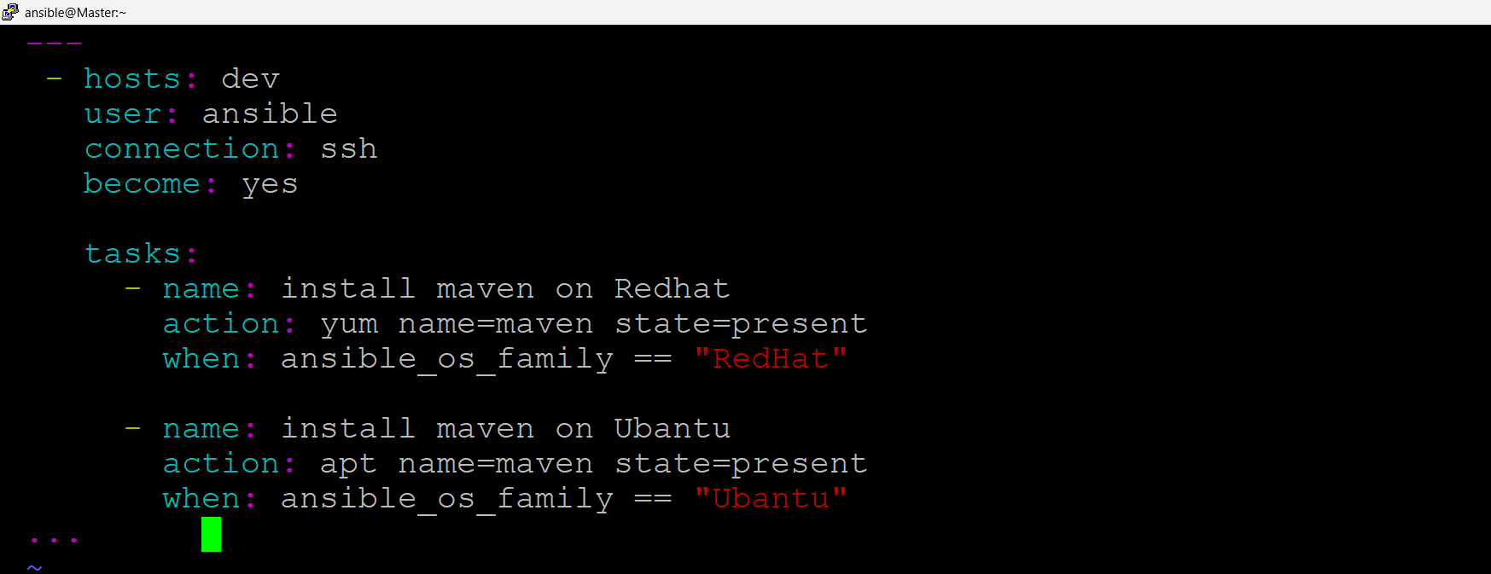

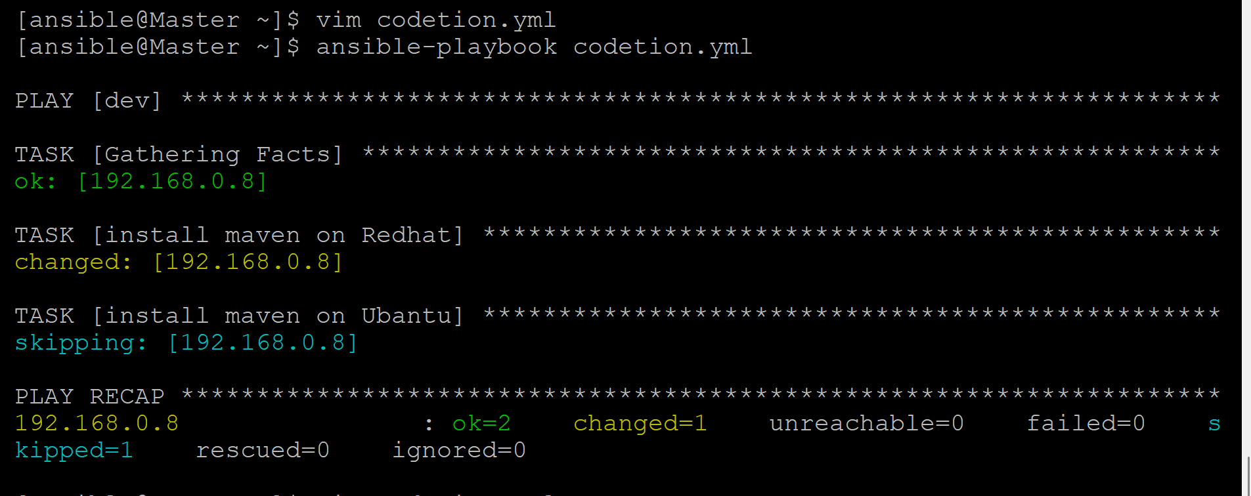

1. **write a playbook to delete user and group in a server**

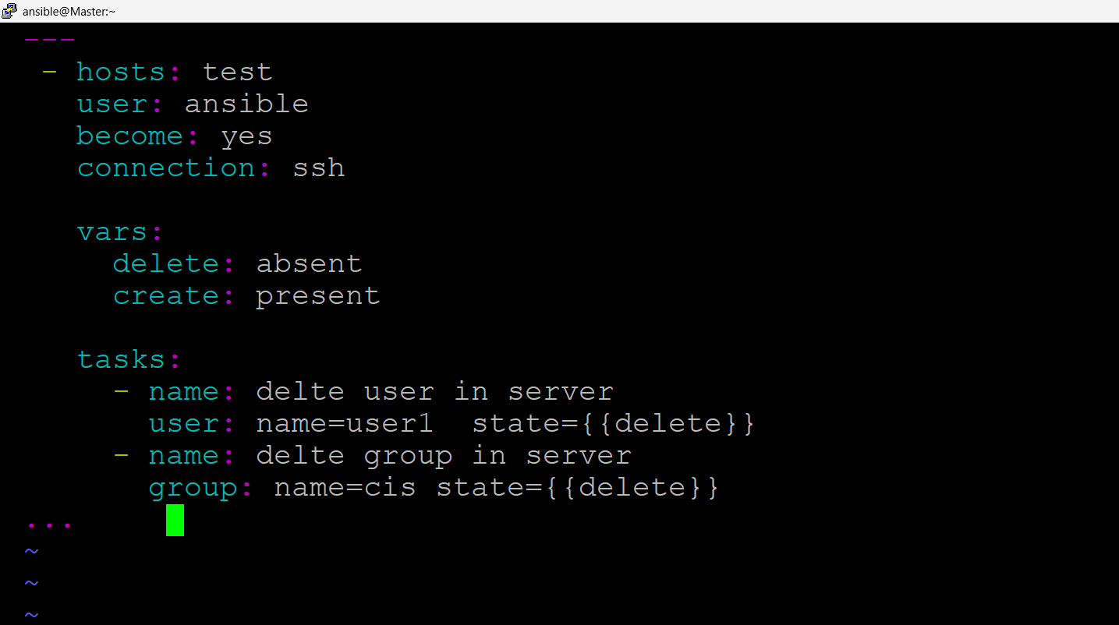

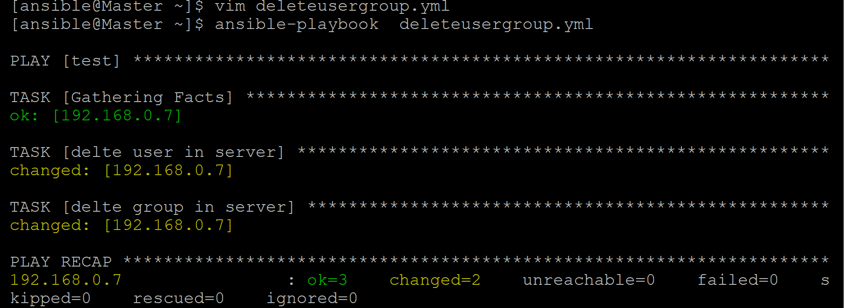

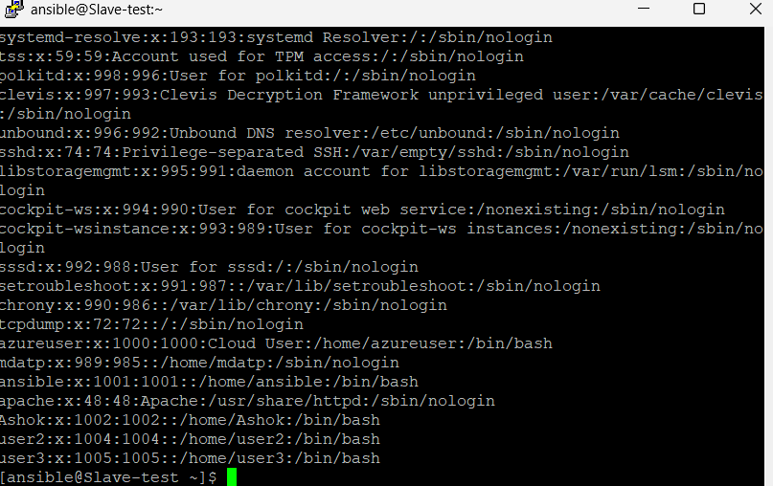

1. **Write a playbook to install Jenkins**

**---**

**- name: Install Jenkins with Java 17 on Red Hat 8.10**

**hosts: all**

**become: yes**

**tasks:**

**- name: Install Java 17**

**yum:**

**name: java-17-openjdk-devel**

**state: present**

**- name: Add Jenkins repository**

**get_url:**

**url: https://pkg.jenkins.io/redhat-stable/jenkins.repo**

**dest: /etc/yum.repos.d/jenkins.repo**

**- name: Import Jenkins GPG key**

**rpm_key:**

**state: present**

**key: https://pkg.jenkins.io/redhat-stable/jenkins.io.key**

**- name: Install Jenkins**

**yum:**

**name: jenkins**

**state: present**

**- name: Configure Jenkins to use Java 17**

**lineinfile:**

**path: /etc/sysconfig/jenkins**

**regexp: '^JENKINS_JAVA_CMD='**

**line: 'JENKINS_JAVA_CMD="/usr/lib/jvm/java-17-openjdk/bin/java"'**

**- name: Start and enable Jenkins service**

**systemd:**

**name: jenkins**

**state: started**

**enabled: yes**

**- name: Open firewall port for Jenkins**

**firewalld:**

**port: 8080/tcp**

**permanent: yes**

**state: enabled**

**- name: Reload firewall**

**command: firewall-cmd –reload**

**---**

**- name: Configure httpd and Jenkins**

**hosts: all**

**become: yes**

**tasks:**

**- name: Install httpd (Apache)**

**yum:**

**name: httpd**

**state: present**

**- name: Start and enable httpd service**

**service:**

**name: httpd**

**state: started**

**enabled: true**

**- name: Configure httpd to listen on port 80**

**lineinfile:**

**path: /etc/httpd/conf/httpd.conf**

**regexp: "^Listen"**

**line: "Listen 80"**

**state: present**

**notify: Restart httpd**

**- name: Install Jenkins**

**yum:**

**name: jenkins**

**state: present**

**- name: Configure Jenkins to listen on port 8080**

**lineinfile:**

**path: /etc/sysconfig/jenkins**

**regexp: "^JENKINS_PORT"**

**line: "JENKINS_PORT=8080"**

**state: present**

**notify: Restart Jenkins**

**- name: Start and enable Jenkins service**

**service:**

**name: jenkins**

**state: started**

**enabled: true**

**handlers:**

**- name: Restart httpd**

**service:**

**name: httpd**

**state: restarted**

**- name: Restart Jenkins**

**service:**

**name: jenkins**

**state: restarted**

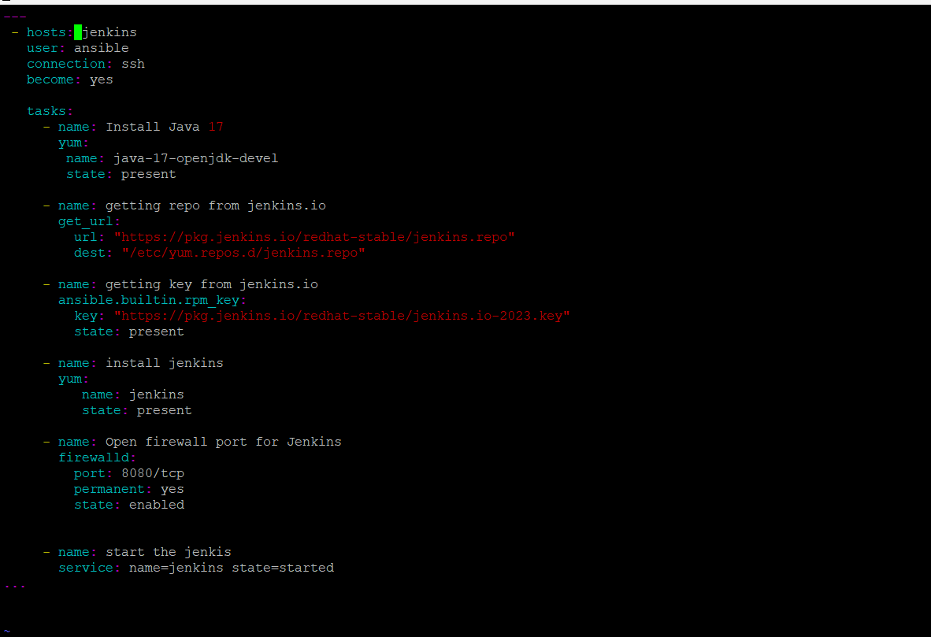

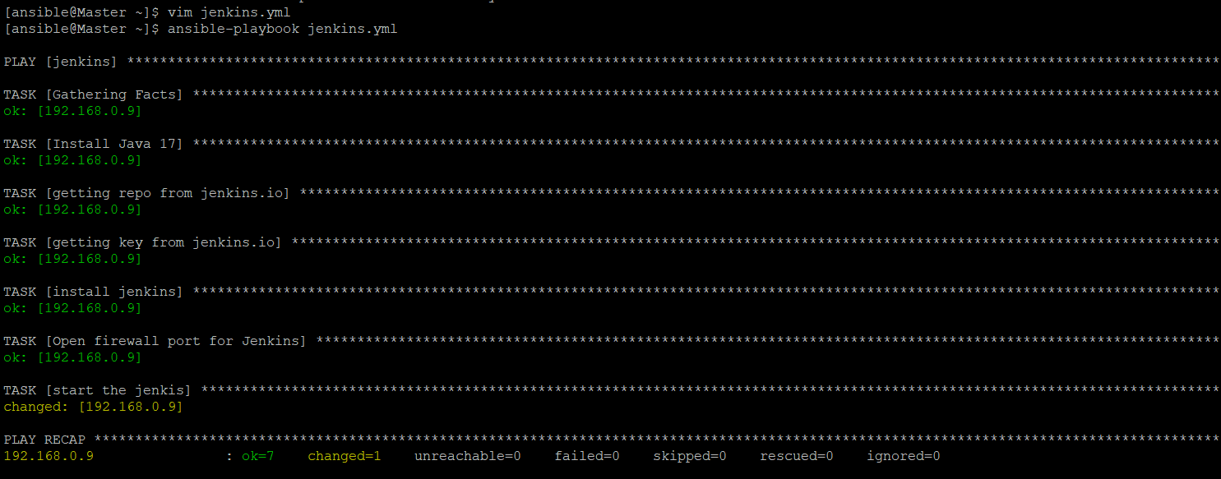

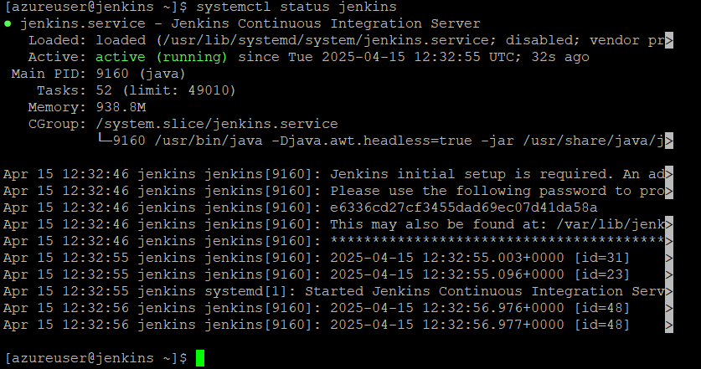

**ashok**

**Ashok@123**

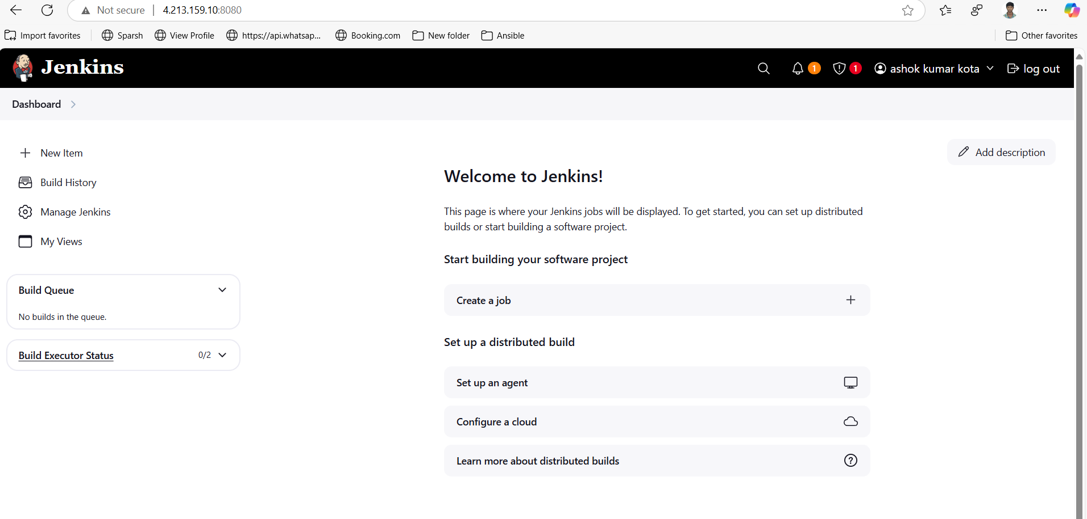

**Some time when we try to install or get the tomcat or any software will get error on that time we have to check the system have internat acces or not if not we have to chek the DNS server is up and running or not.**

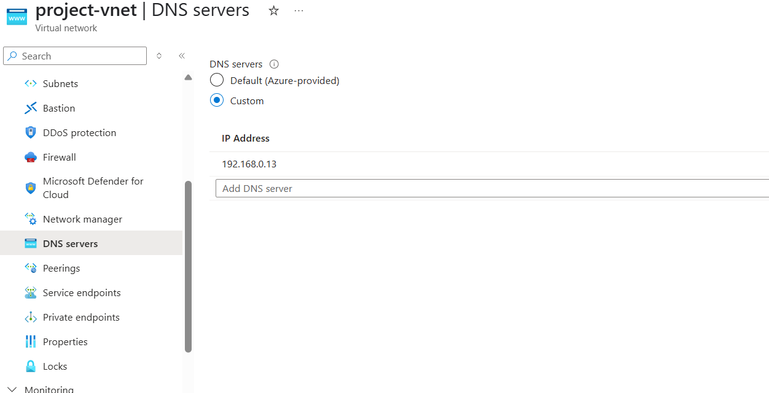

**Manuval process to setup tomcat**

**wget https://dlcdn.apache.org/tomcat/tomcat-9/v9.0.104/bin/apache-tomcat-9.0.104.tar.gz**

**tar -zxvf apache-tomcat-9.0.104.tar.gz**

**cd apache-tomcat-9.0.104**

**cd conf**

**vim tomcat-users.xml**

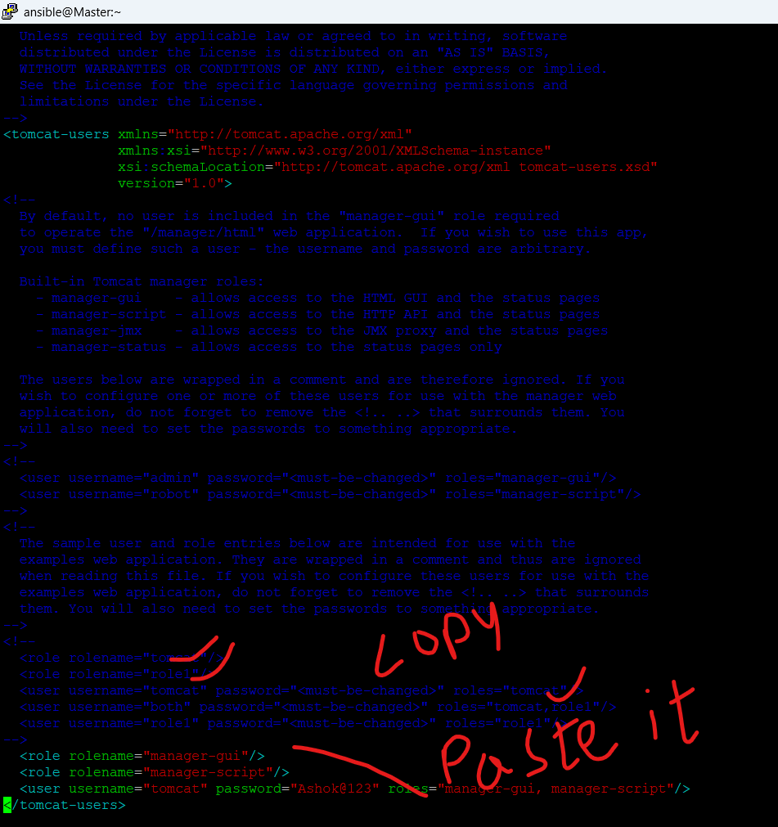

**cd apache-tomcat-9.0.104**

**cd webapps/manager/META-INF**

**vim context.xml**

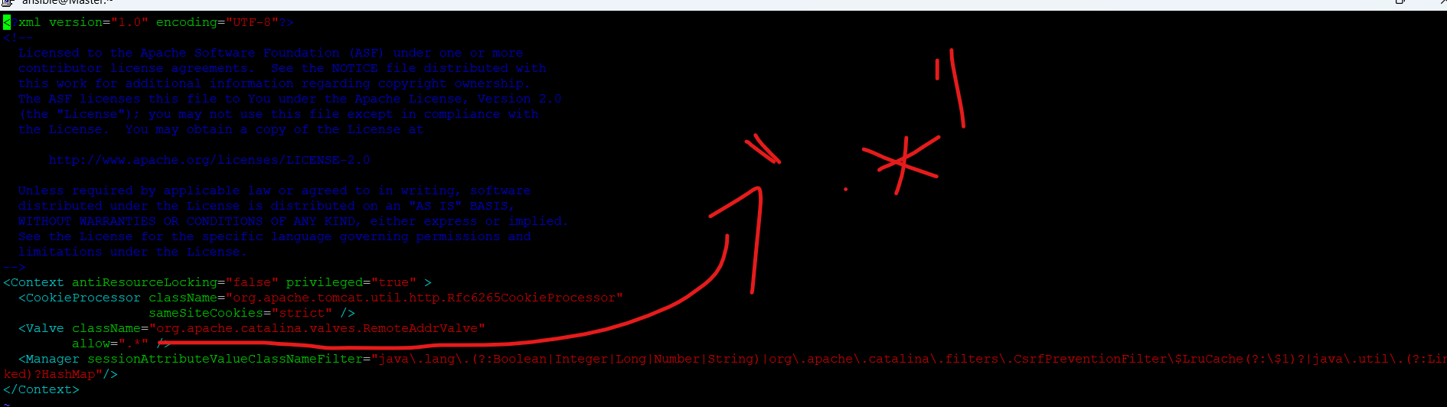

**We have to replace with “.*” with the existing values**

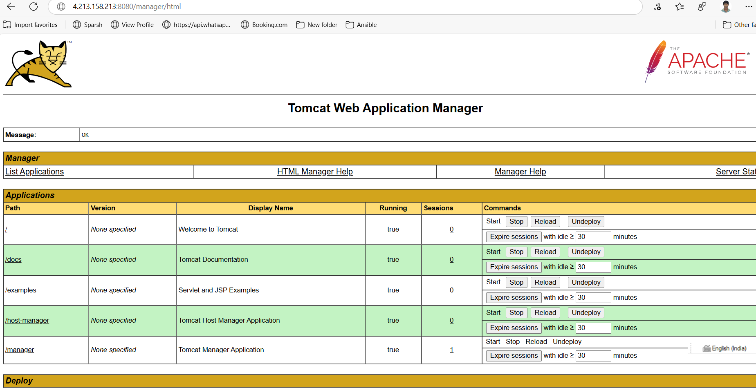

**The above setup is manual**

**For this same deployment to setup multiple servers using ansible playbook we have follow below steps with the above steps.**

**cd apache-tomcat-9.0.104**

**cd conf**

**cp tomcat-users.xml /home/ansible**

**cd apache-tomcat-9.0.104**

**cd webapps/manager/ META-INF**

**cp context.xml /home/ansible**

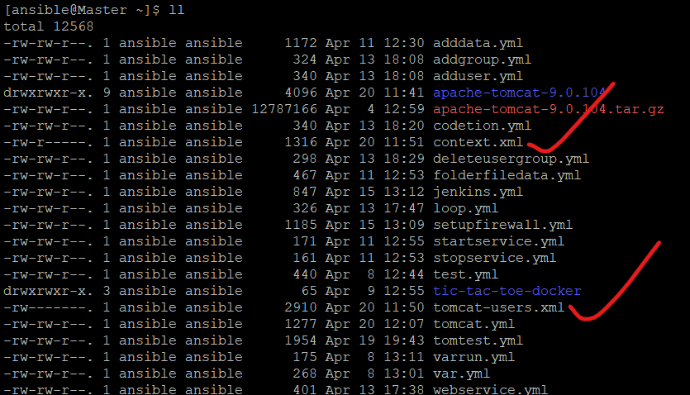

**vim tomcat.yml**

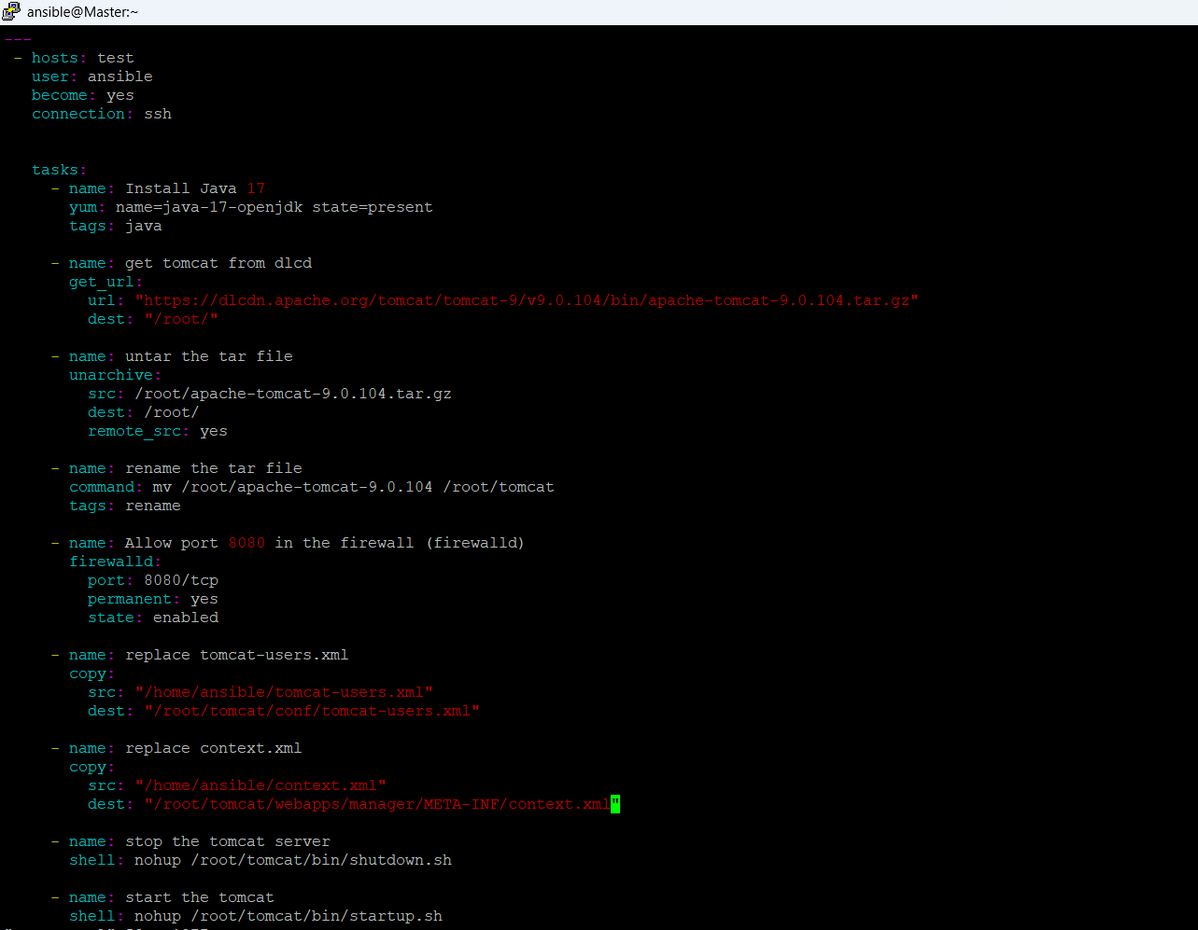

**ansible-playbook tomcat.yml --skip-tag="rename"**

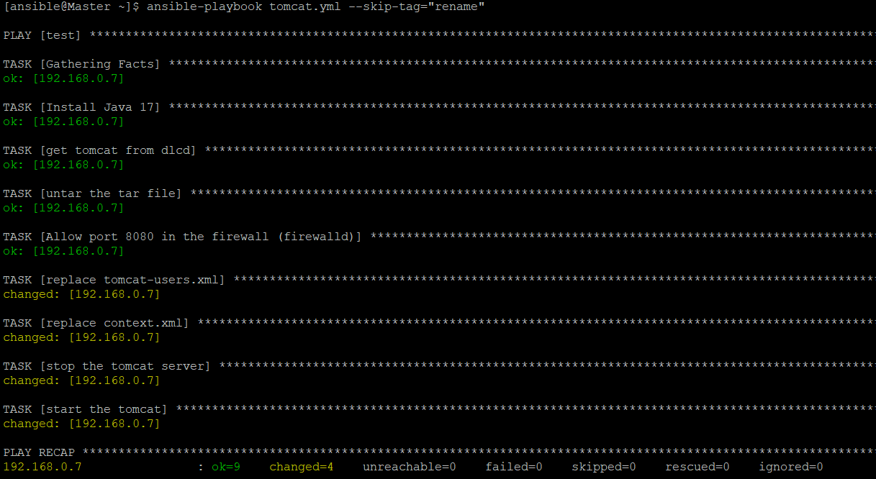

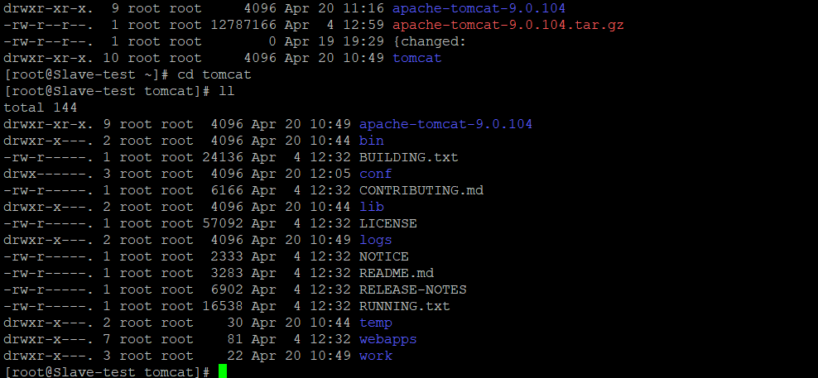

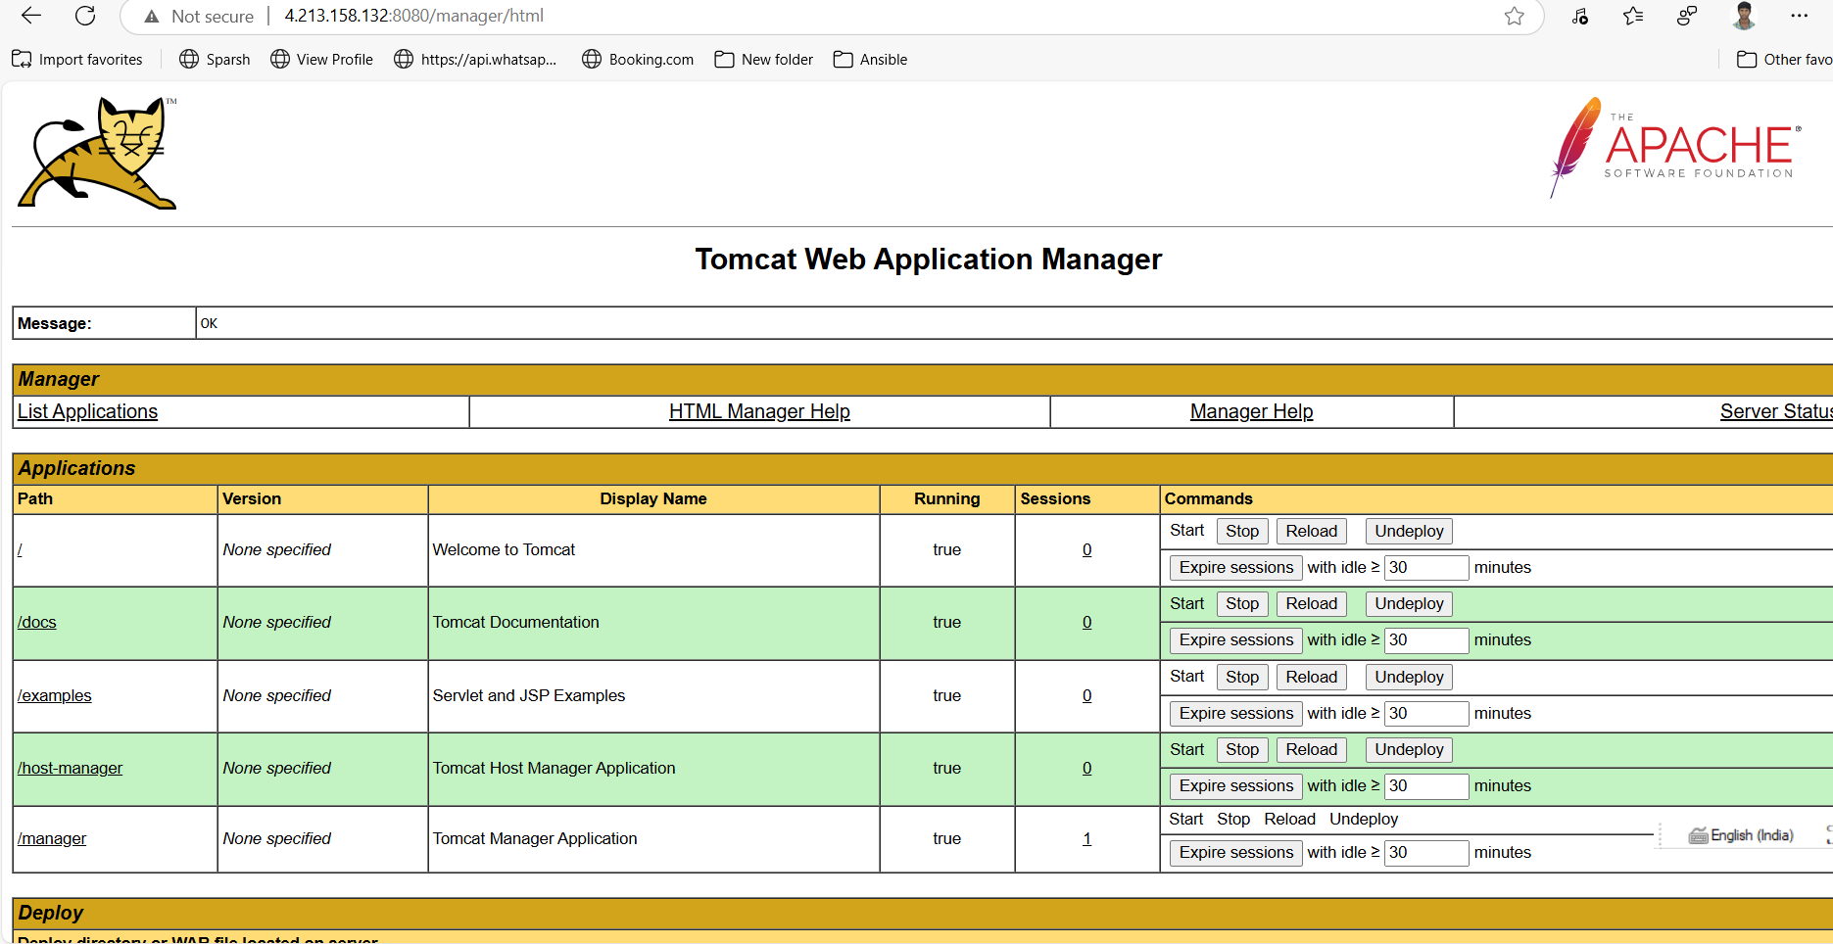

**9. Write a play book to use tags for skip the particular task**

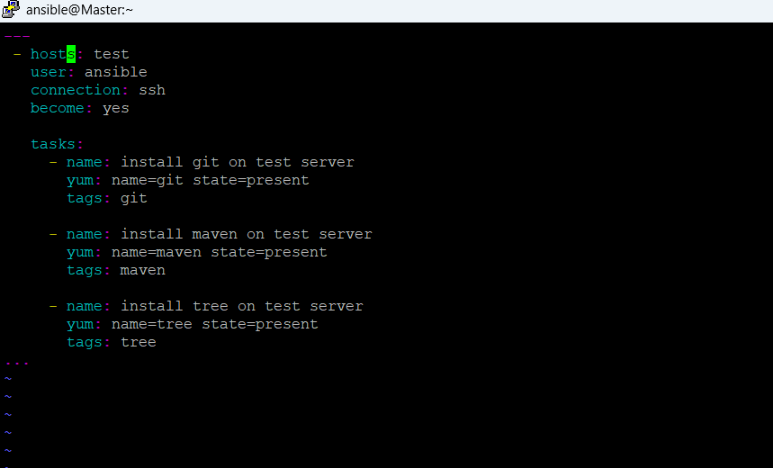

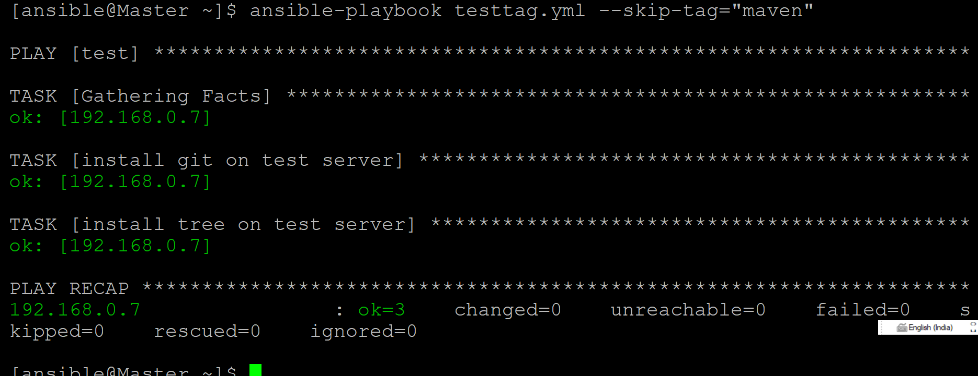

**10.Write a play book to run particulat task**



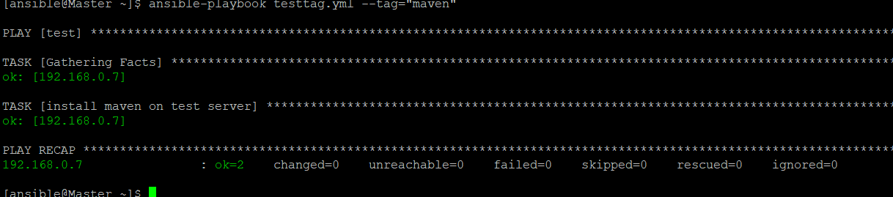

1. **Write a play book to get git repo files on slave server**

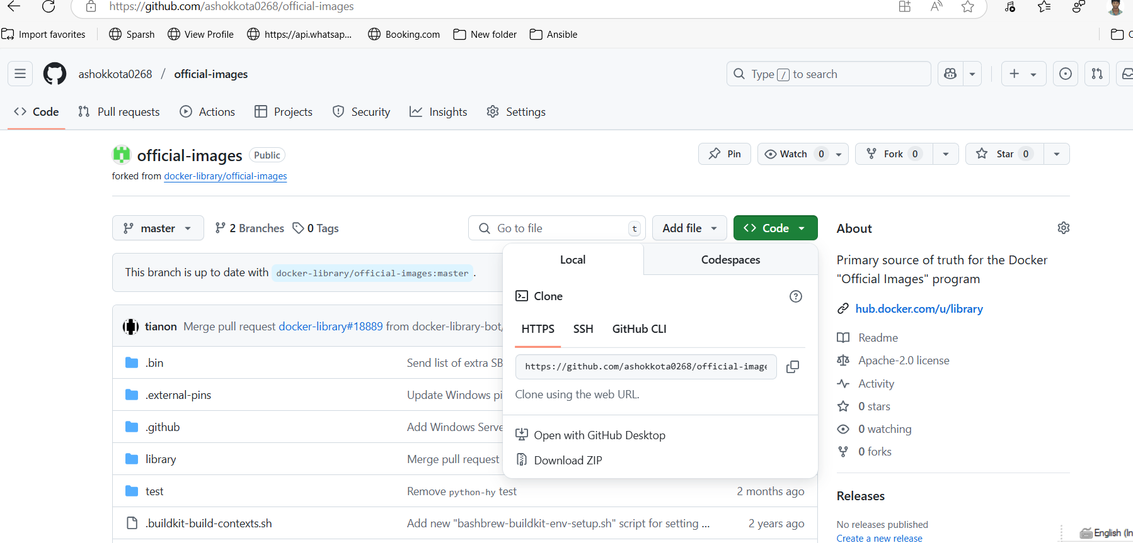

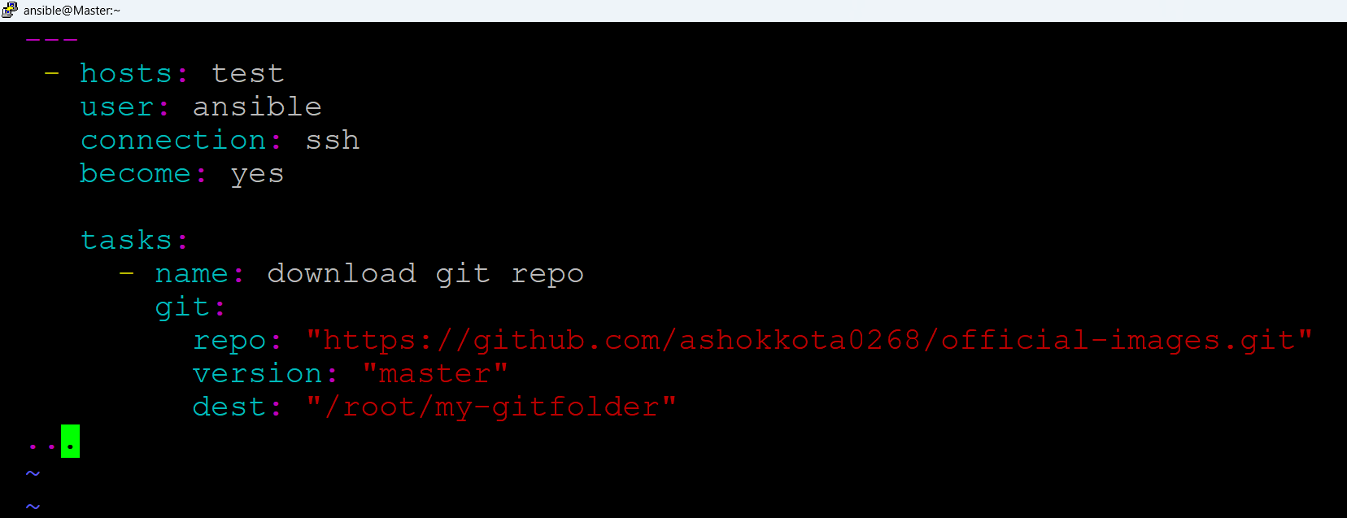

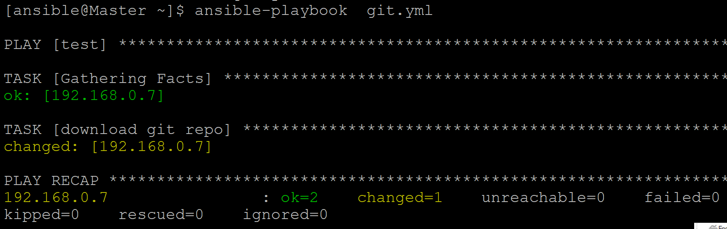

**Output:**

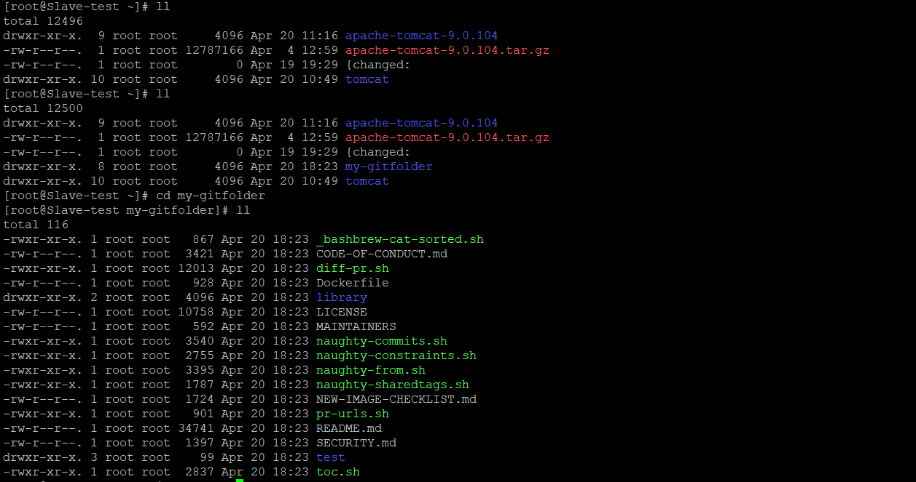

**Git private repo**

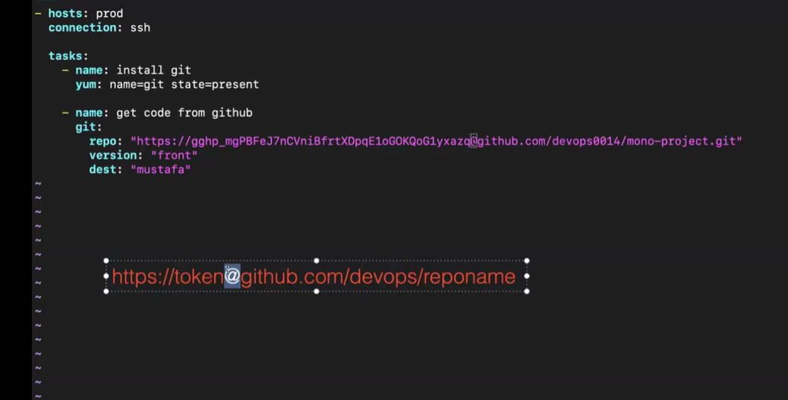

**Run Ansible playbook from Jenkins**

**1.We have to install publish over SSh plugin from Avaible plugins**

**Manage Jenkins>plugins>Available plugins**

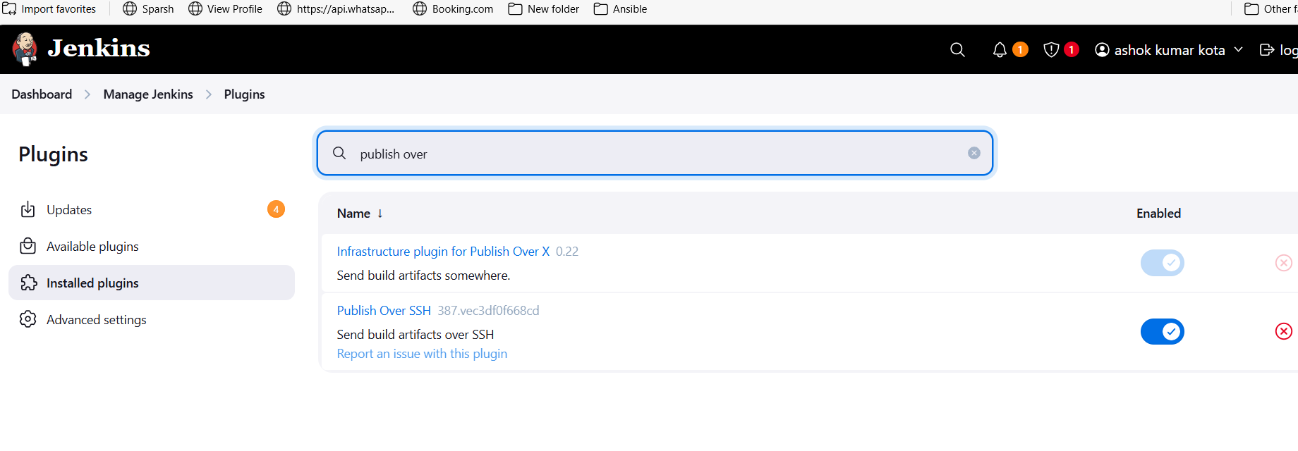

**We have to setup publish over ssh**

**Manage Jenkins> System >publish over ssh**

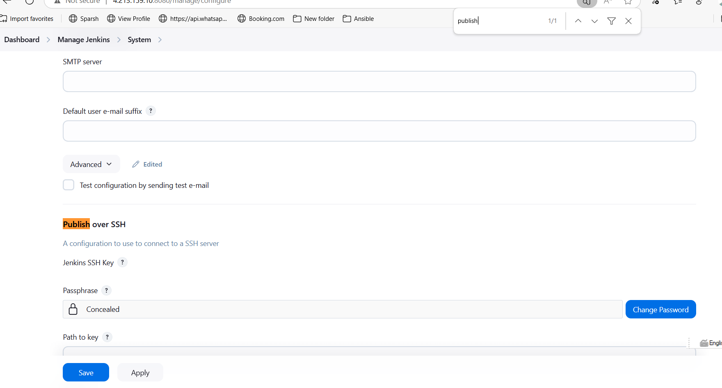

**SSh Server > Add > Name (any thing)> Hostname > Master server ip(pub or private) > Ansible server user name (how we connect the master server)**

**Ex: my master server ip : 192.168.0.6**

**User name: ansible**

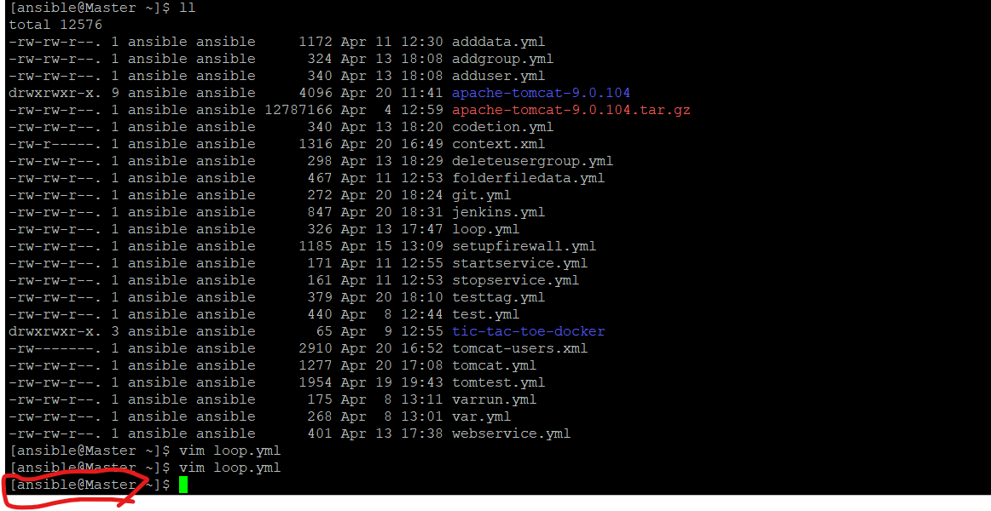

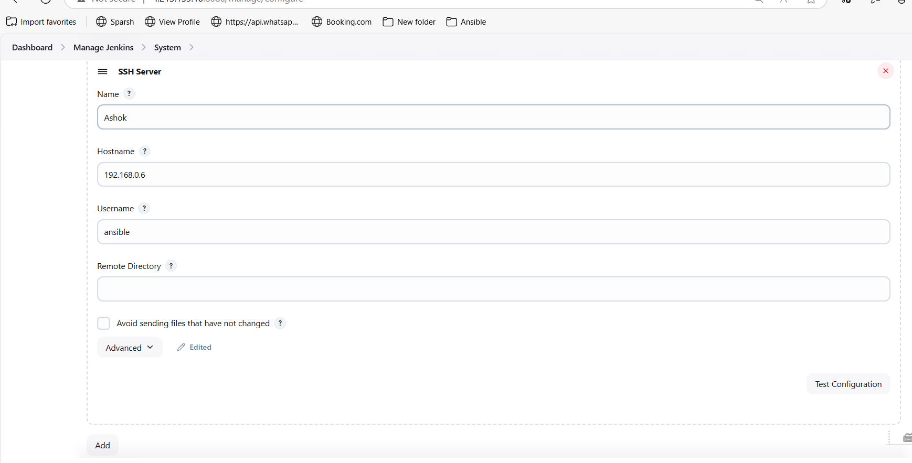

**Test configuration if it’s success then save it.**

**Create a new job > free style > Send file or execute commands over ssh before the build starts > name (it will come by default ) > source file (your playbook) > Exec command (executable command) > save and build it**

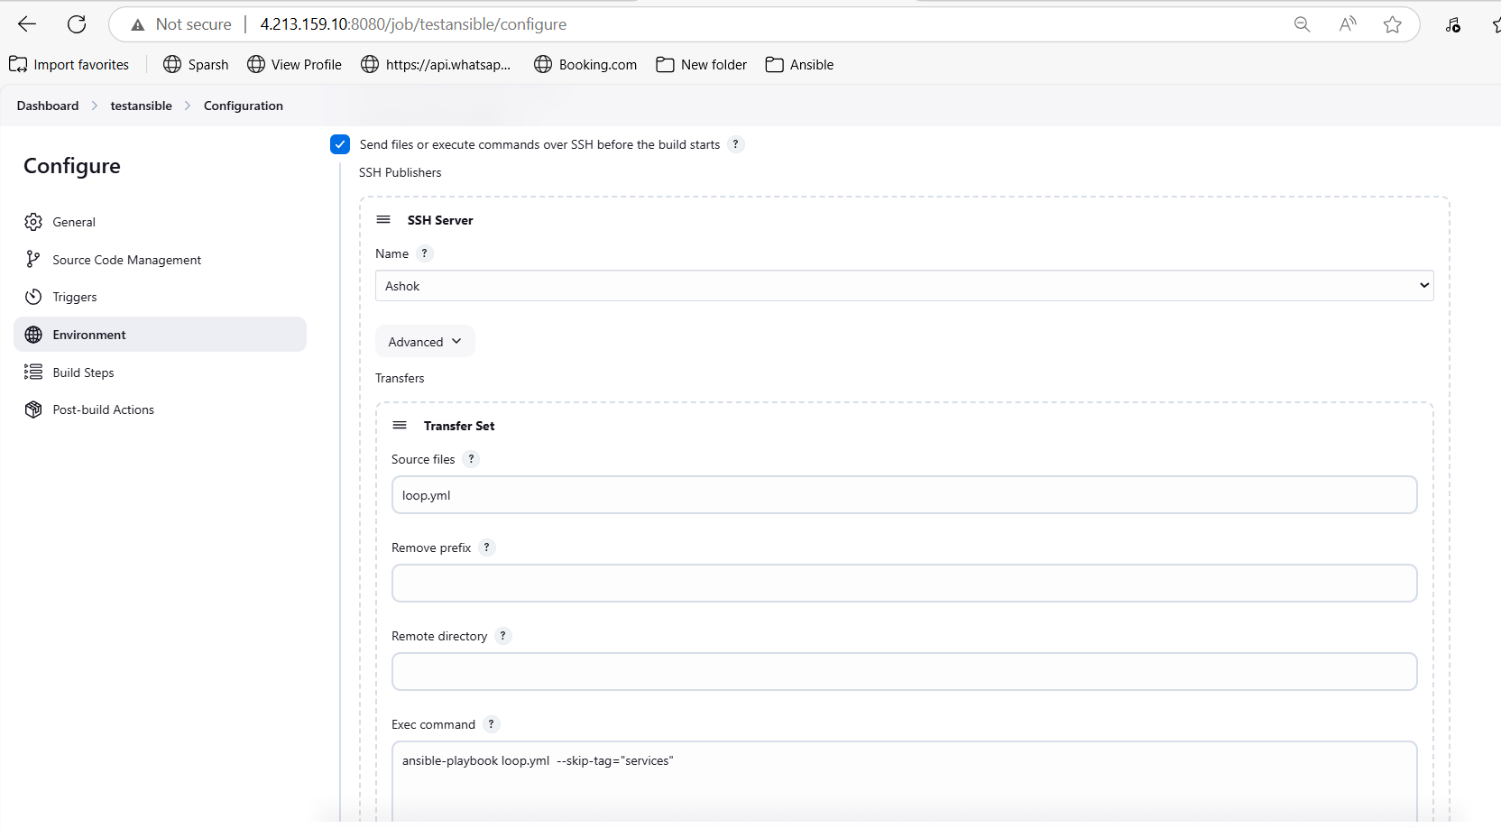

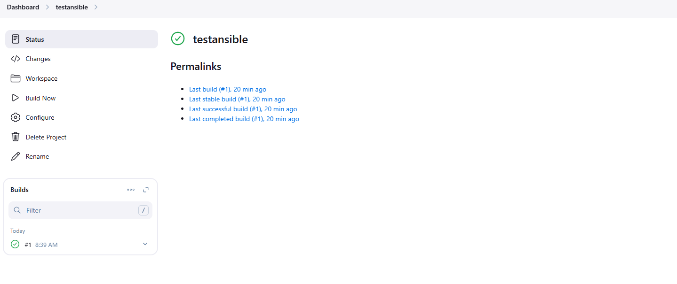

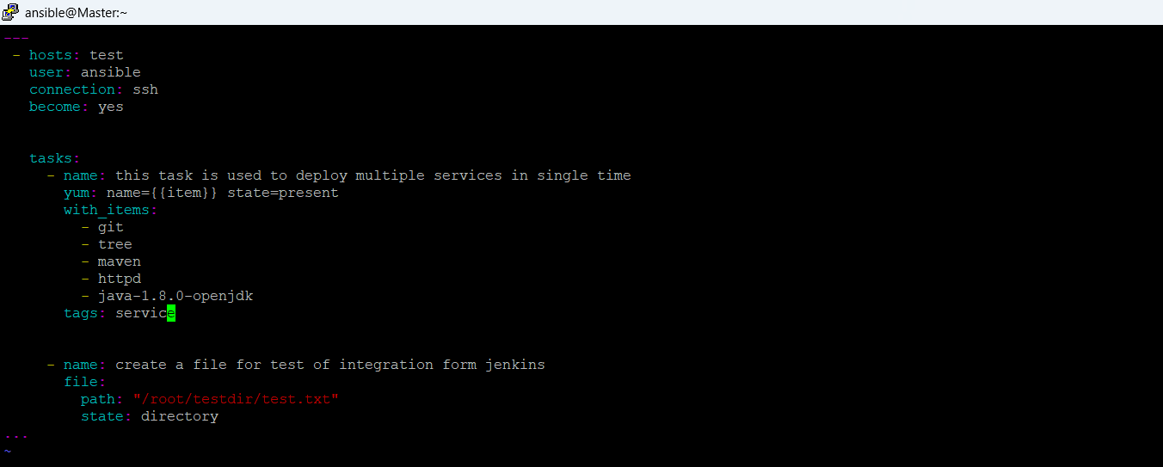

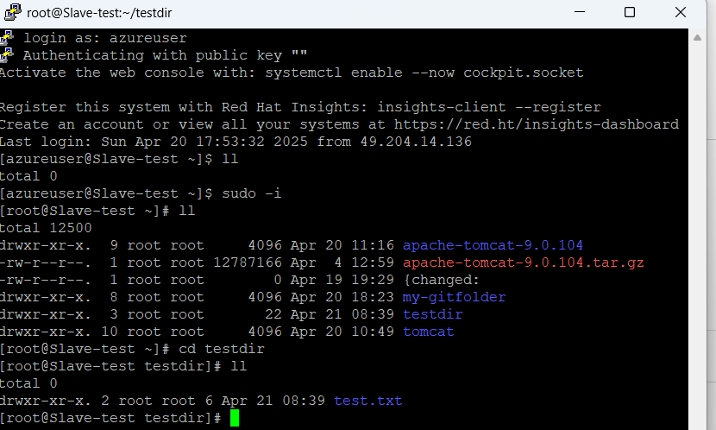

**If we write anything wrong in play book the build will go to unstable**

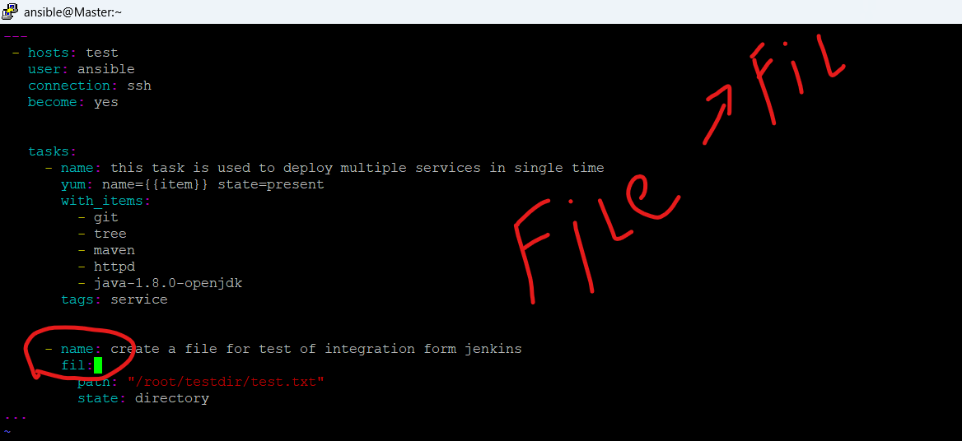

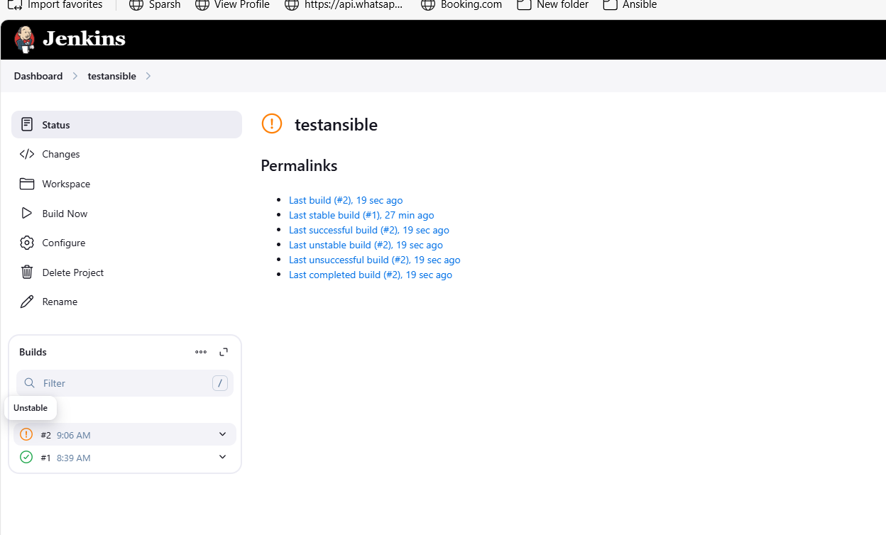

**Ansible Handlers**

**Whenever the first task will perform on that time only the (handlers) second task will be execute.**

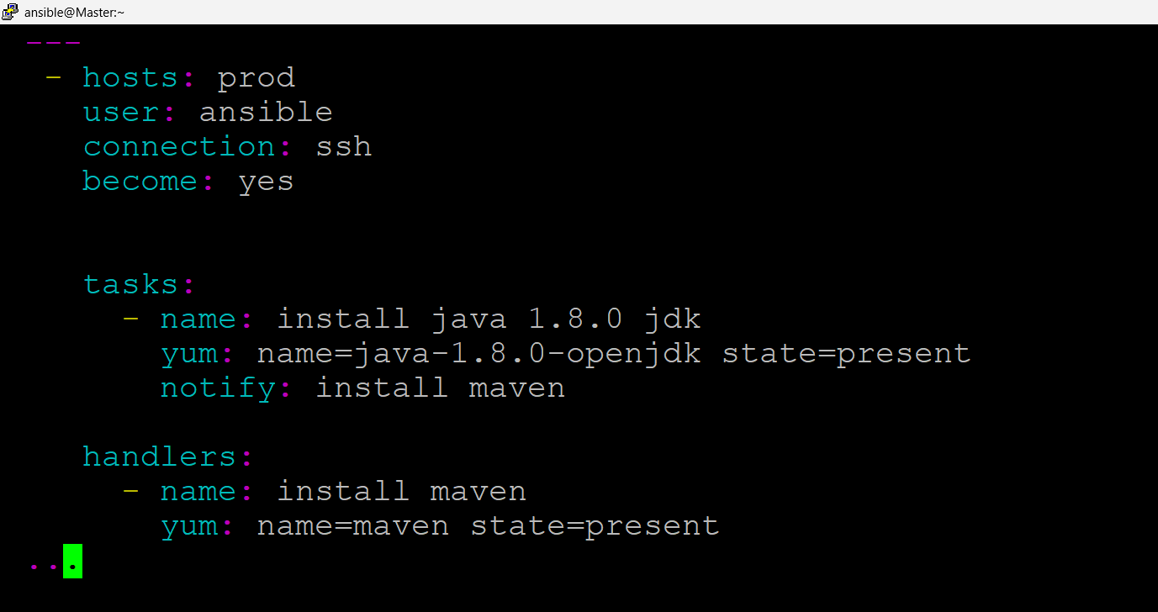

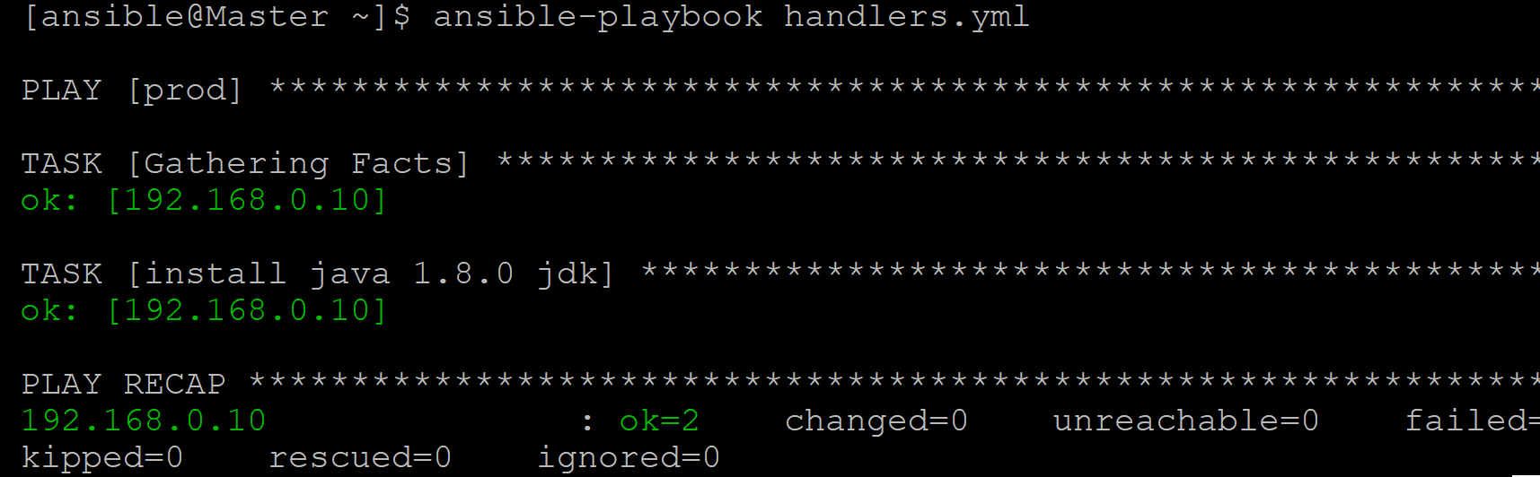

**On my prod server I have already installed the java 1.8.0 , so this is not install again so it was skipped handler task as weel**

**Because neenu playbook lo em rassanu antey naa tasks lo ishina task perform aytene naa handlers lo unna action perform avvali ani but neenu already naa prod server lo java 1.8.0 install cheseyadam valana java aneadi malli install avvaleadu (ok ) ani vastey already andulo install ayyi undi ani meening, changed ani vastey task perform ayyindi ani meening.**

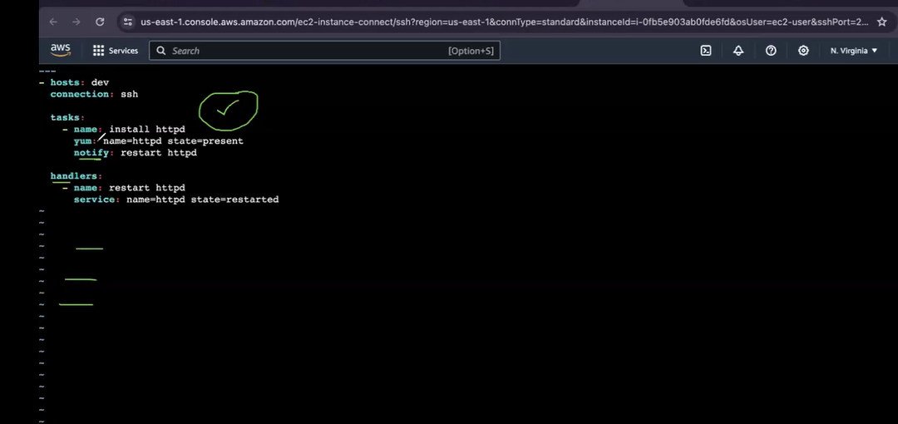

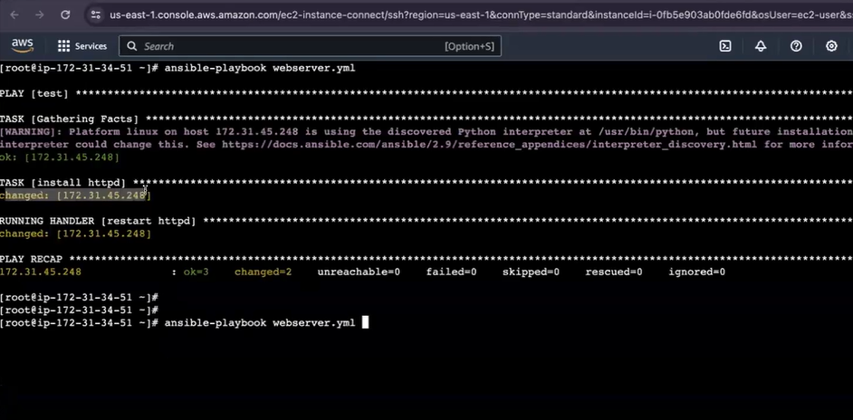

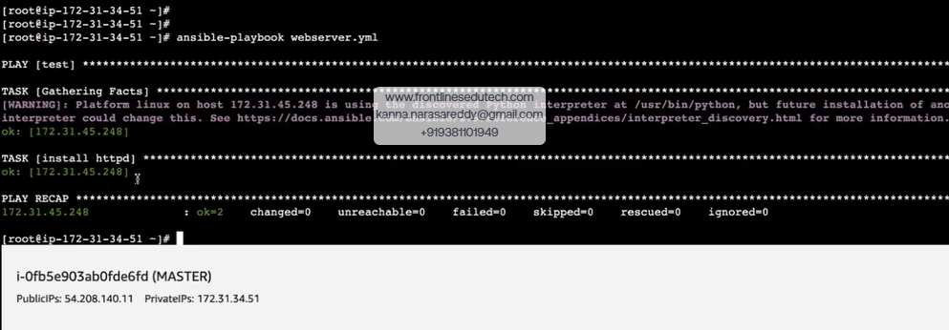

**Ansible-valut**

**If you want secure the data or encrypt the data 🡪ansible-vault encrypt playbook name**

**new vault passwd:1234**

**Confirm new vault password: 1234**

**Cat playbook name**

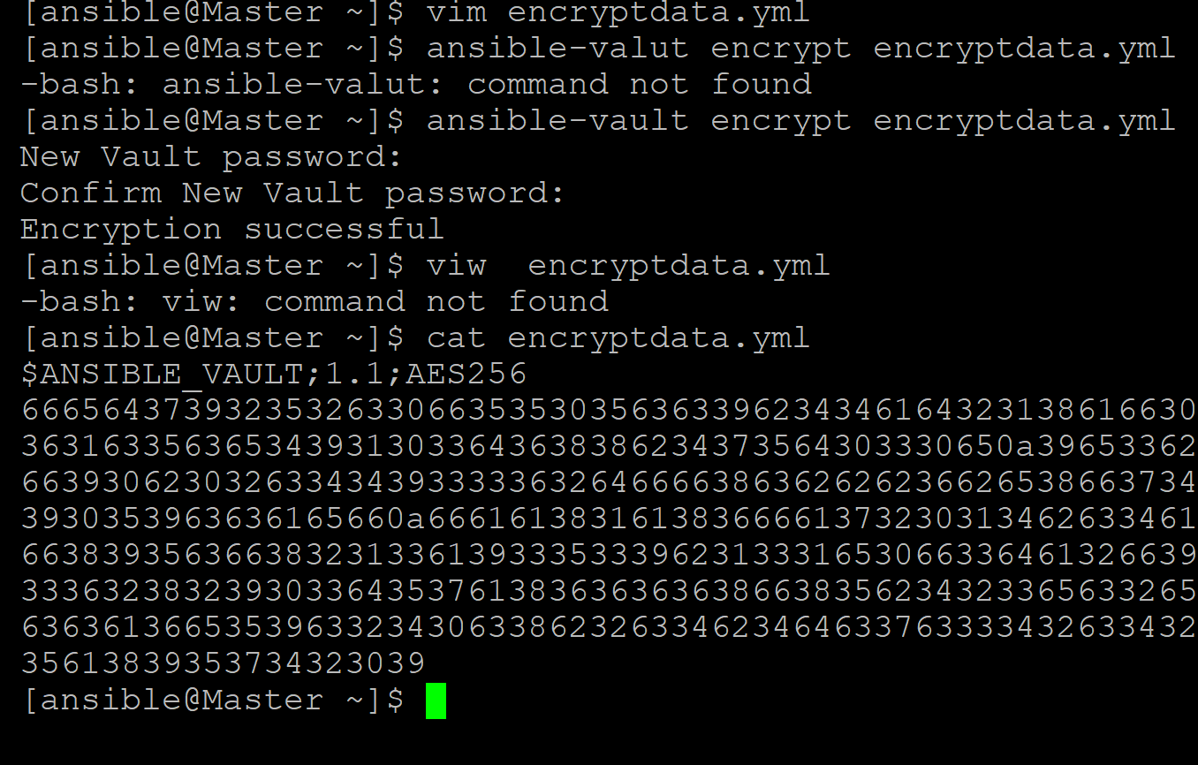

**If you want decrypt the data 🡪 ansible-vault decrypt playbook name**

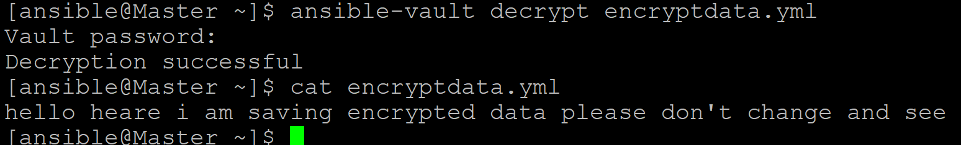

**If you want see the data without decrypt the data**

**Ansible-vault view encryptdata.yml**



**If you want to see the ansible-vault keys**

* **Ansible-vault**

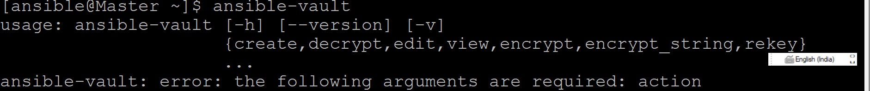

**If you want to change the encrypted key**

**Ansible-vault rekey playbook name**

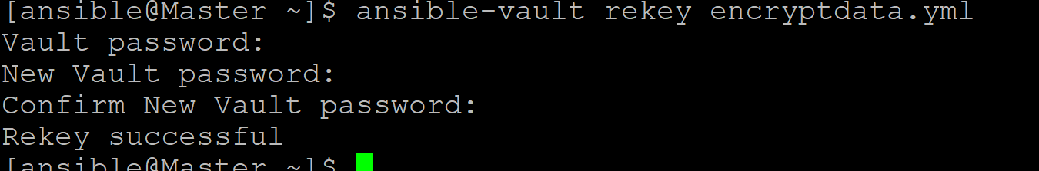

**If you forget the key we can’t do anything 😂 our data will be loss**

**We have to save this keys very securely using azure key vault or any other secure places**

**To create a file using encrypted format**

**Ansible-vault create playbook or file name**



**>> We can’t change the data with out decrypt the file**

**Roles**

**This role concept we use for devied the task to multiple users**

**16 . write a play book to setup tomcat by dividing task to multiple users**

**mkdir myapps**

**cd myapps**

**vim main.ymm**

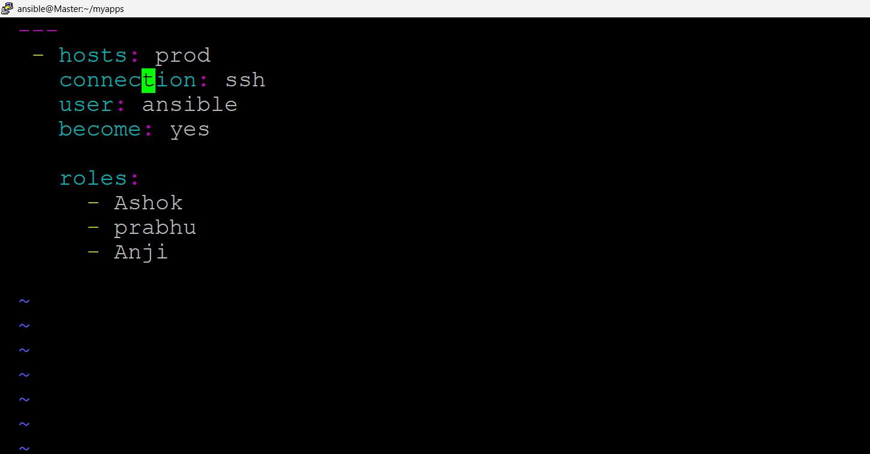

**mkdir roles**

**cd roles**

**mkdir Ashok Prabhu Anji**

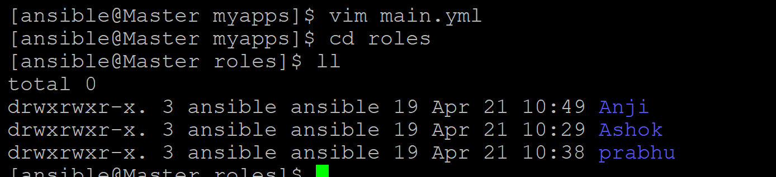

**cd Ashok**

**mkdir tasks**

**cd tasks**

**vim main.yml**

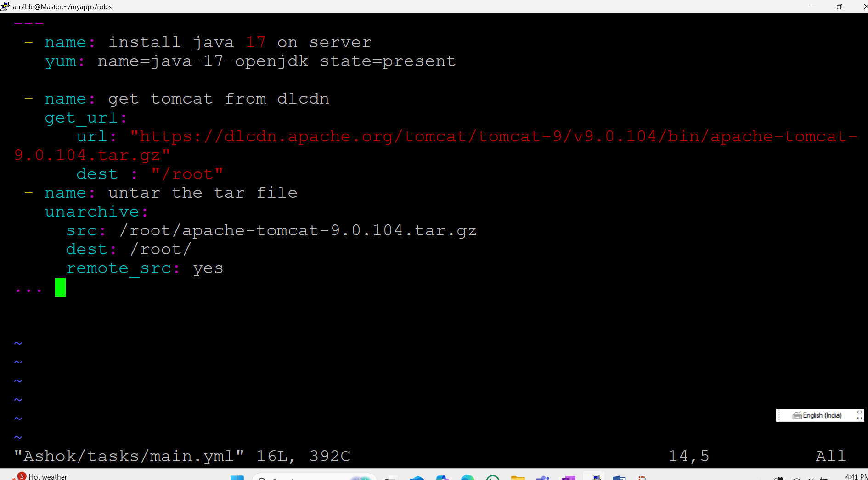

**cd prabhu**

**mkdir tasks**

**cd tasks**

**vim main.yml**

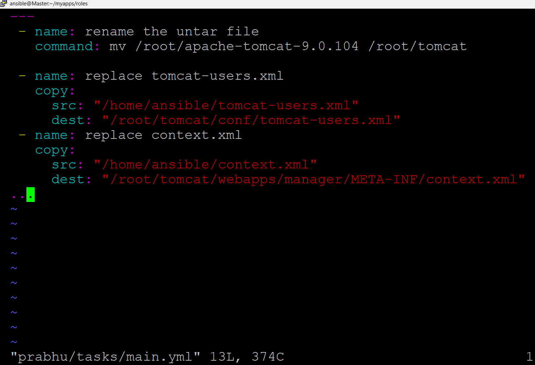

**cd Anji**

**mkdir tasks**

**cd tasks**

**vim main.yml**

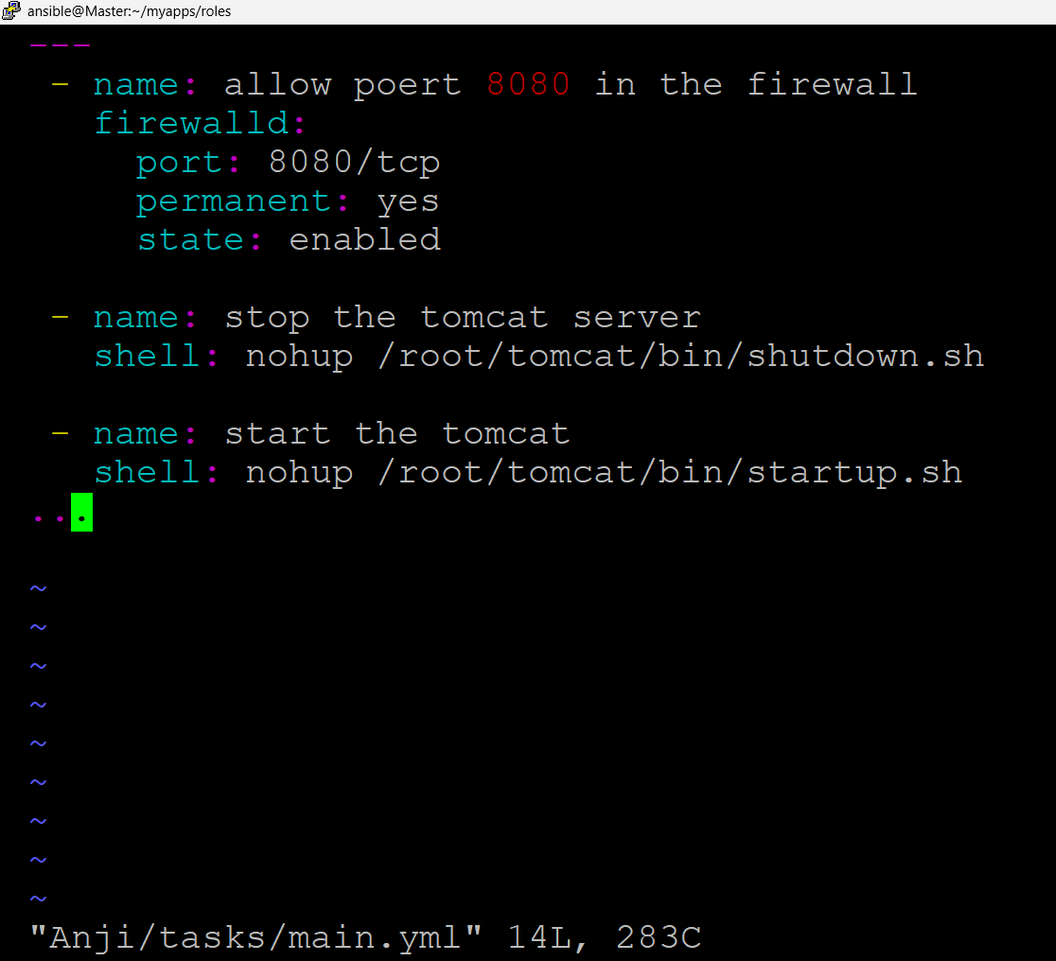

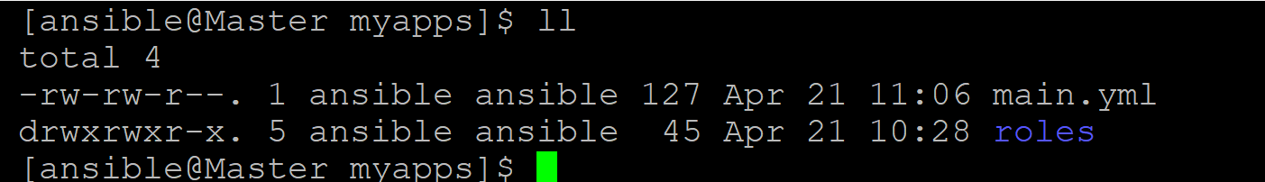

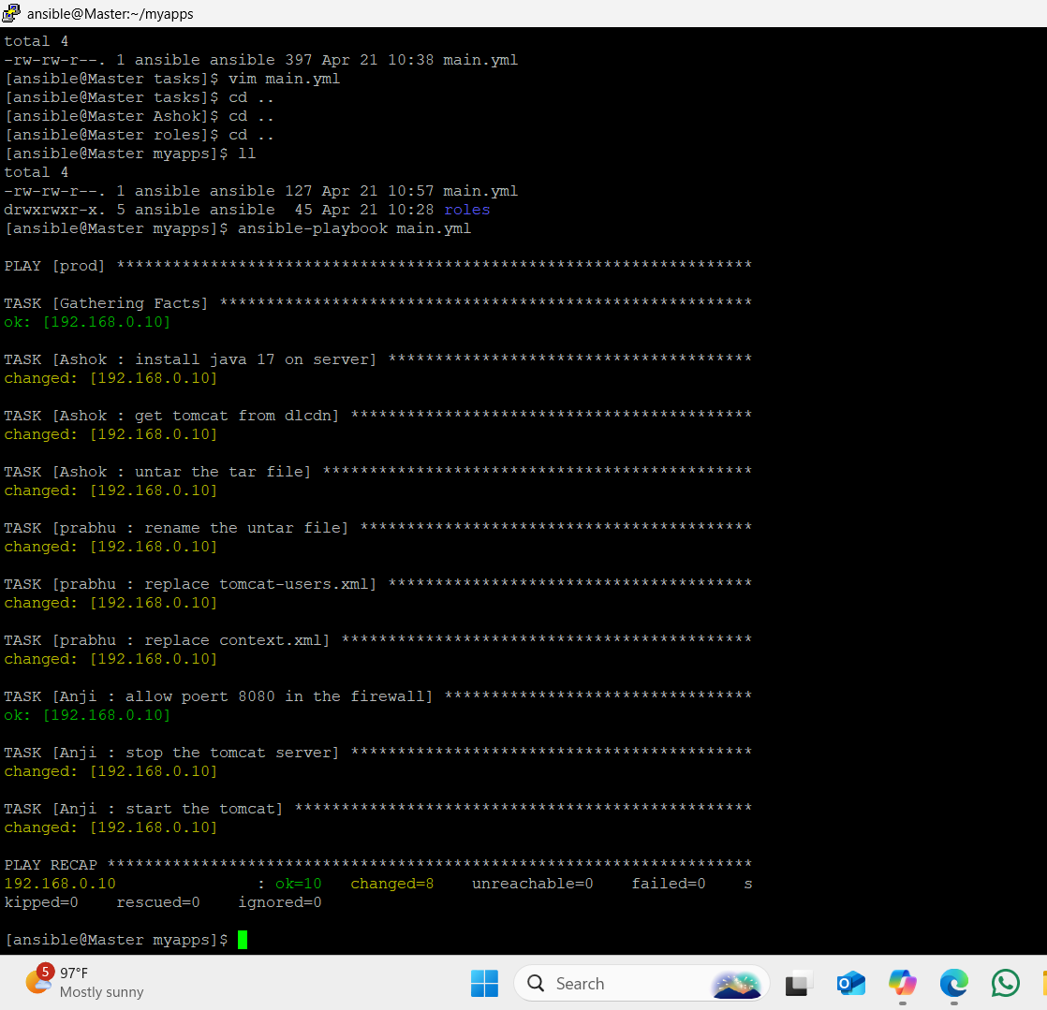

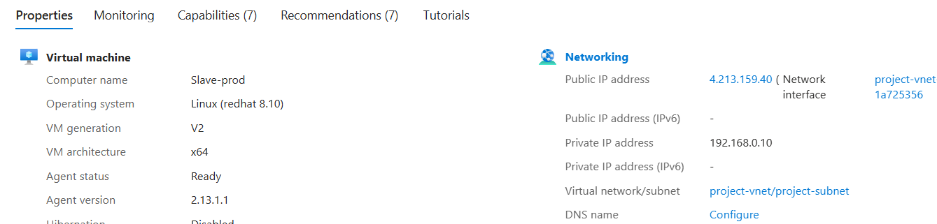

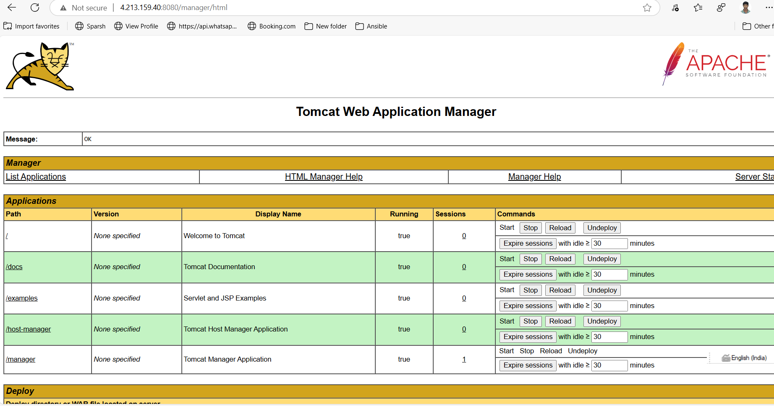



**When we try to install using yum or action or command if it’s not working on that time we can use raw module**

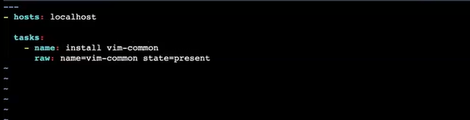

**Debug**

**Ansible setup modules**

**Debug module we are using most of the scenarios it will help a lot**

1. **If we want to see slave server os(the slave server working on which os)**

* **Hosts: all**

**User: ansible**

**Connection: ssh**

**Become: yes**

**tasks:**

**- Debug:**

**msg: “slave server working on {{ansible_os_family}}”.**

**- Debug:**

**msg: “slave server working on {{ansible_devices}}”.**

**- Debug:**

**msg: “slave server working on {{ansible_kernel}}”.**

**- Debug:**

**msg: “slave server memory{{ansible_memory_mb.real}}”.**

**- Debug:**

**msg: “slave server tptsl memory{{ansible_memory_mb.real.total}}”.**

**- Debug:**

**msg: “slave server free memory is{{ansible_memory_mb.real.free}}”.**

**- Debug:**

**msg: “slave server used memory {{ansible_memory_mb.real.used}}”.**

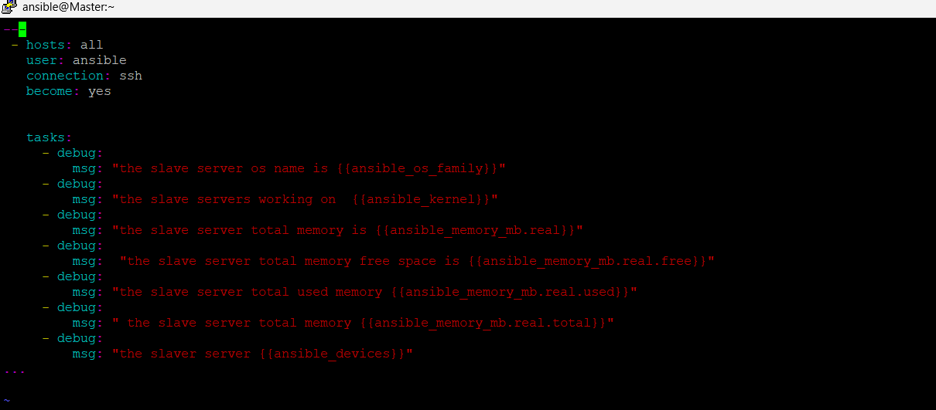

**What ever command we have perform that command data will store in one regitory and using that registory we can see the data in ansible playbook executable**

* **Hosts: all**

**User: ansible**

**Connection: ssh**

**Become: yes**

**Tasks:**

**- Name: to check the git status**

**Command: git –v**

**Register: abc**

**-debug:**

**Msg: “to check the gi status {{abc.stdout}}”**

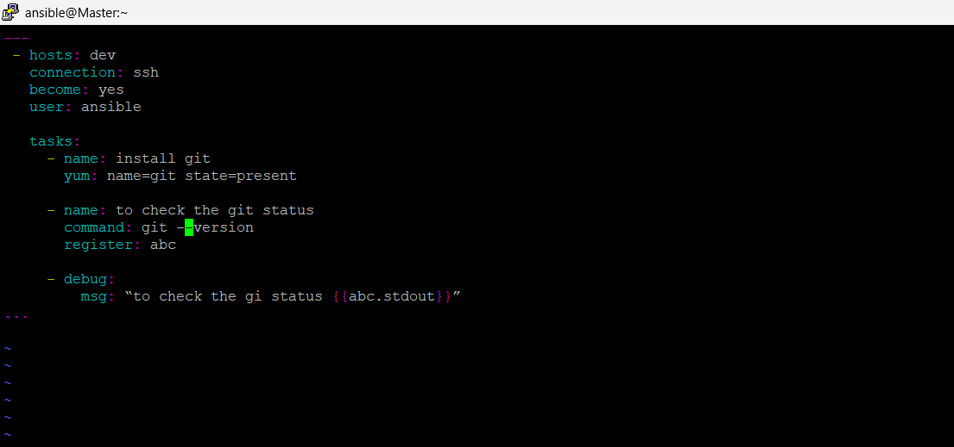

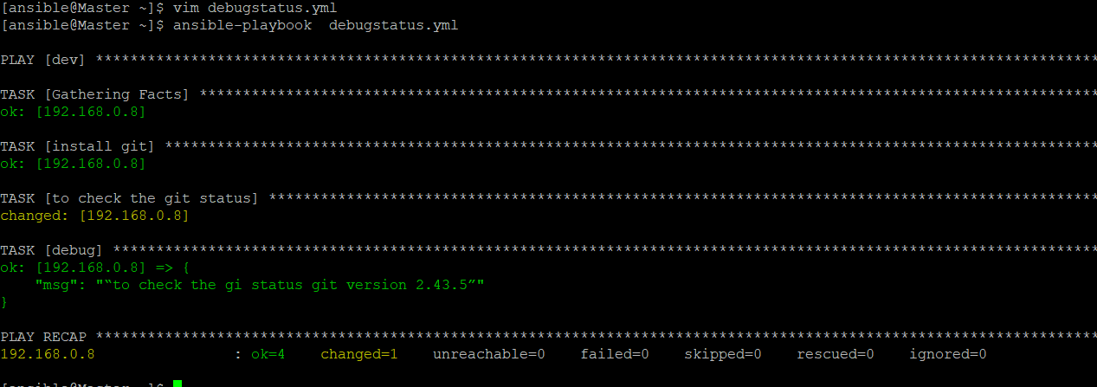

**Ansible Ad-hoc commands**

**Using Ansible ad-hoc commands we can istall any packages from master to slave server with out write any play book but we can’t reuse this commands multiple times like play book.**

**Ex: ansible all – m yum –a “pkg= git state=present”**

**All🡺 all your hosts**

**-m 🡪Module**

**-a🡪 Argument**

**Pkg🡪package**

**-b🡪become**

**To install java -1.8.0-openjdk on Jenkins server**

**Ansible Jenkins –b –m yum –a “pkg=java-1.8.0-openjdk state=present”**

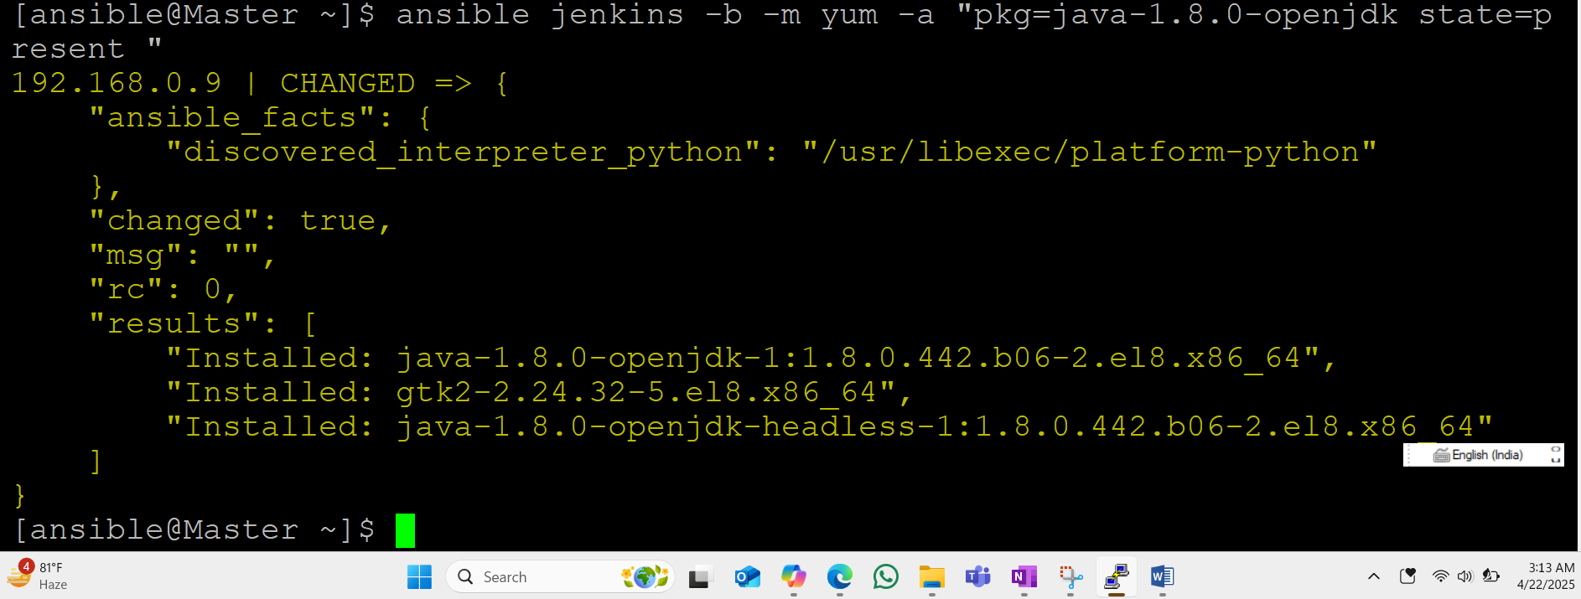

**Ansible Jenkins –b –m yum –a “pkg=git state=present”**

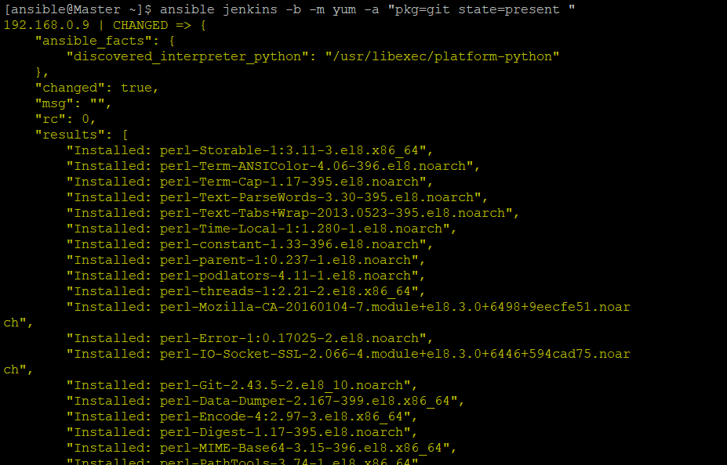

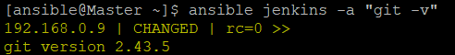

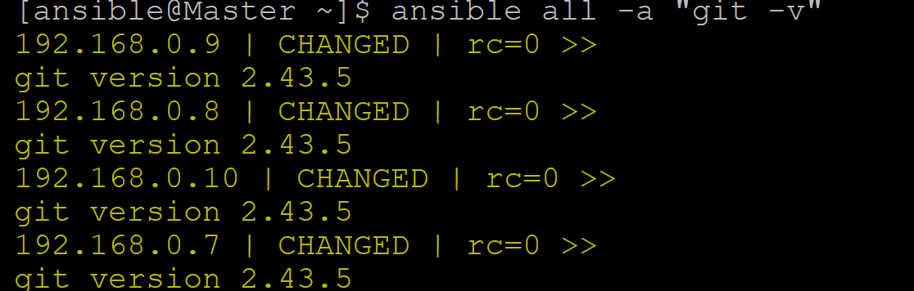

**To check the memory**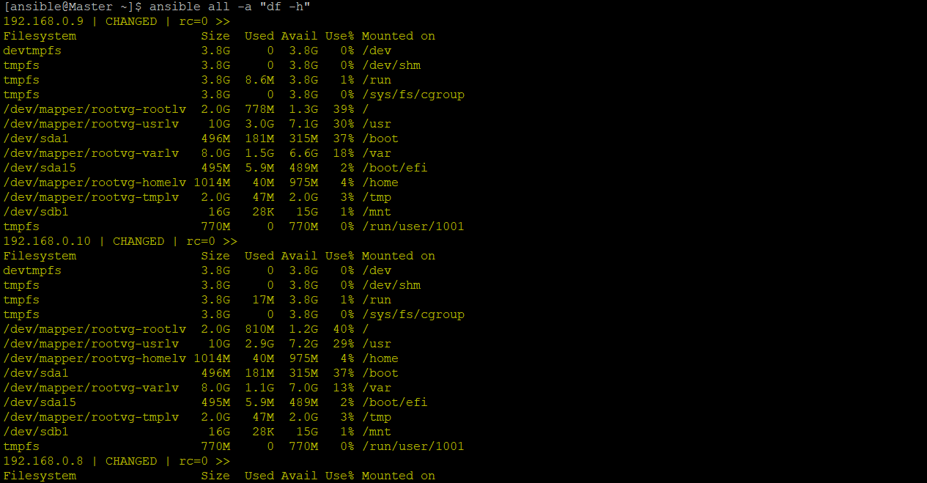

**To check the ls –a**



**To create a directory**

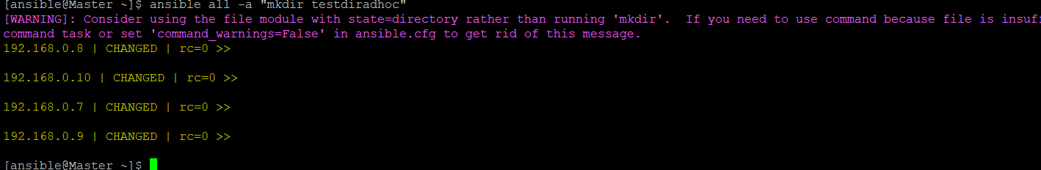

**To check the dir**

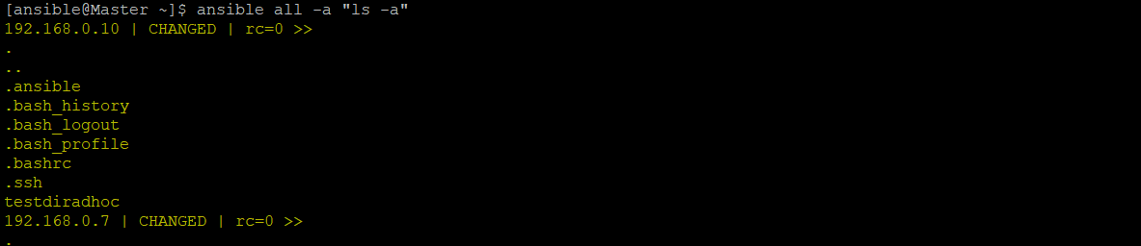

**To create a file**

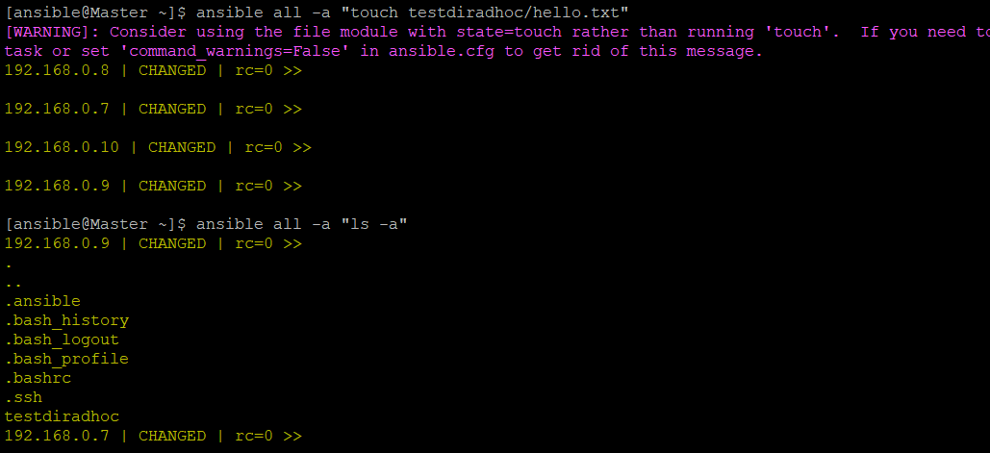

**Copy module**



